Big Data Analytics – Task 1 coursework -P2725708

Introduction

I am going to analyse the criminal activities taking place in Leicester and the city of London from January 2022 to December 2022. We have obtained this information from an official website which is named “DATA.POLICE.UK”. This data is available to the public and may be used for analysis purposes to understand criminal activities in more detail e.g., crime types, location, etc.

Key findings

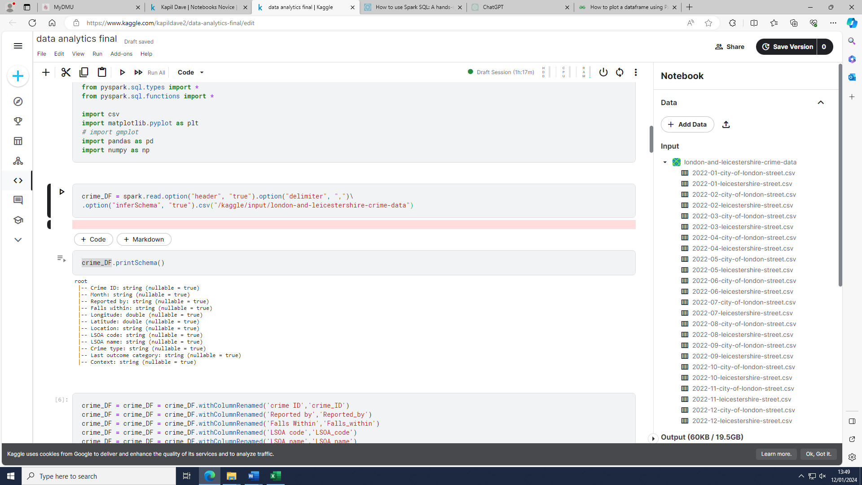

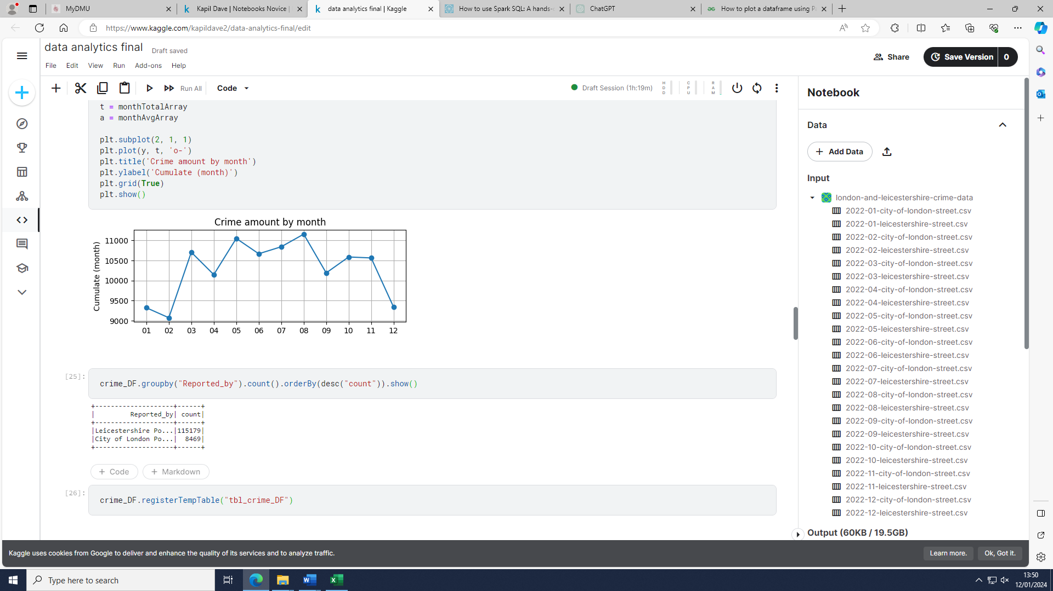

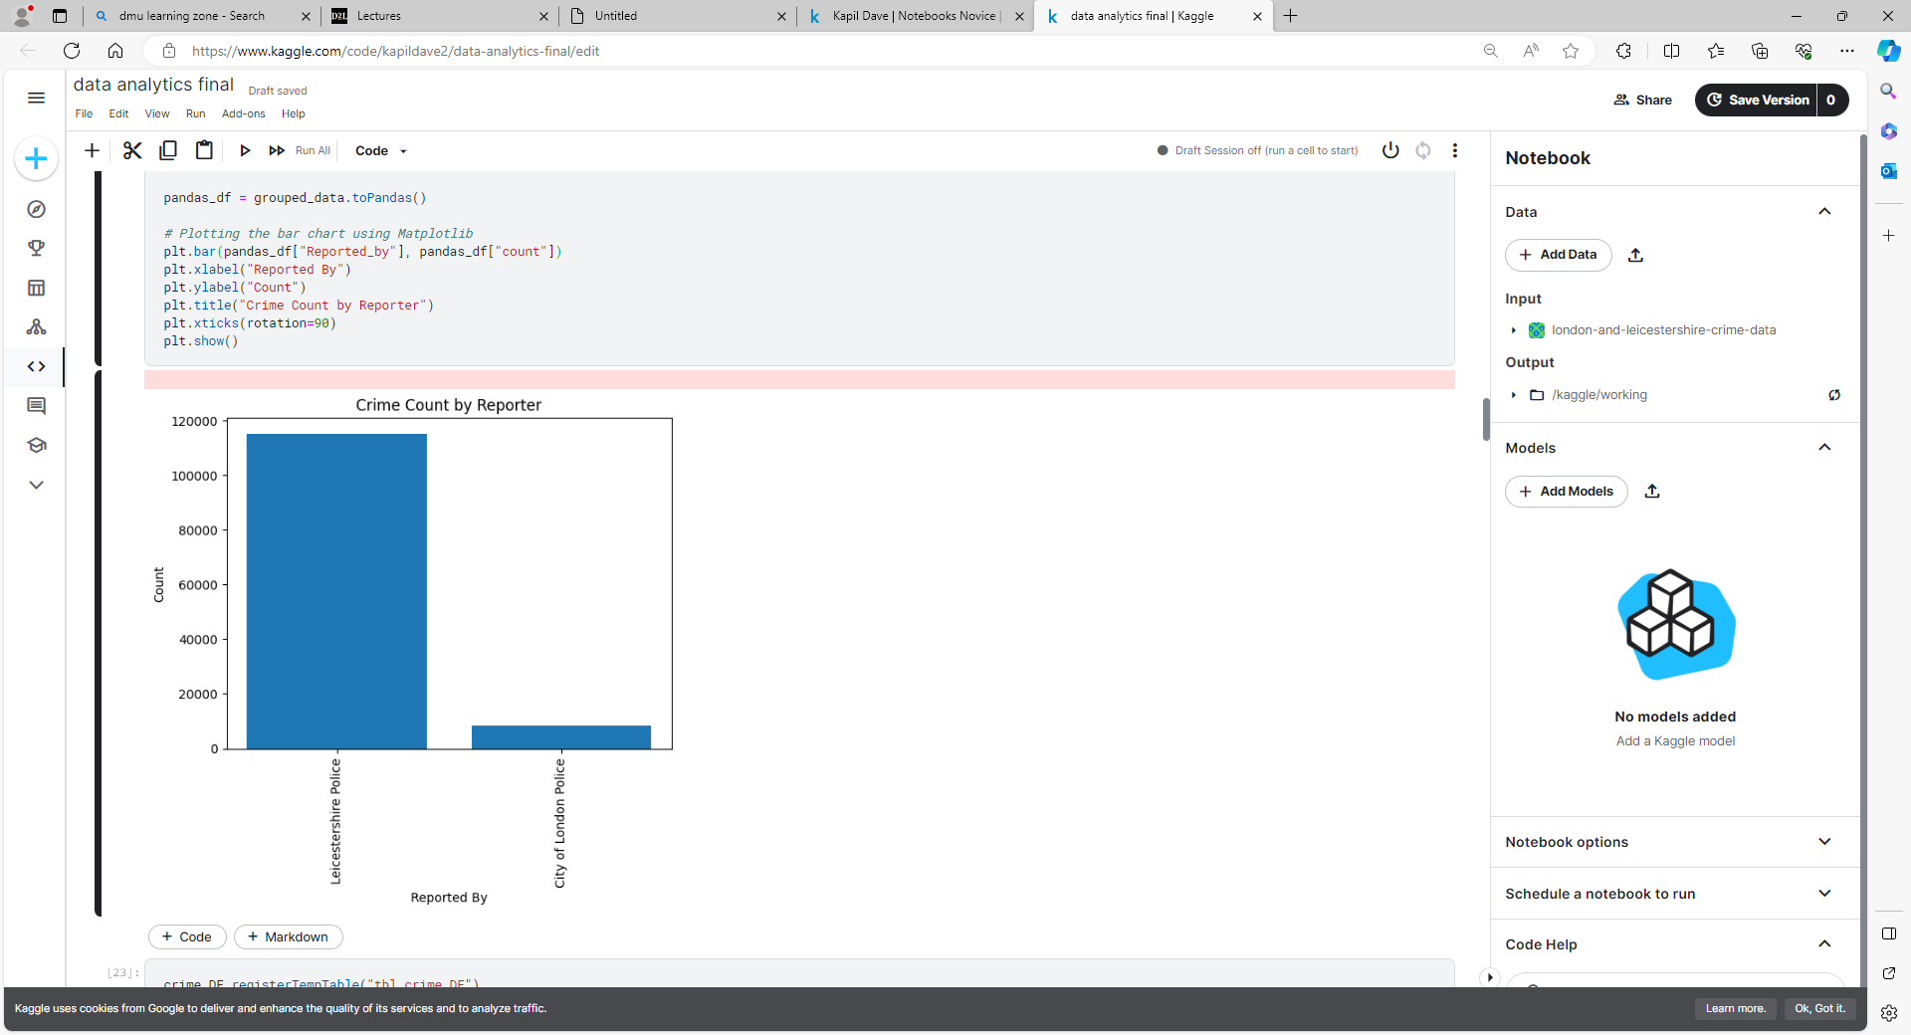

From the visuals and statistics, it is evident that the amount of crime in Leicestershire was significantly higher as compared to the City of London Police (by a scale factor of 13.6). This could be skewed by the fact that Leicestershire police covers 2500 square kilometers whereas the City of London only covers 2.9 square kilometers (www.leics.police.uk, n.d.) (Greater London | county, England, United Kingdom | Britannica, 2019). Providing this significant difference in area would naturally mean the difference in population is as significant with there being 712,000 residents in Leicestershire and 8600 residents in the City of London as of 2021 (Office for National Statistics, 2022) (www.leicestershire.gov.uk, n.d). With the City of London having a high density of influential people the density of the police force per square KM would also be greater which may lead to less crimes reported relative to Leicestershire Police.

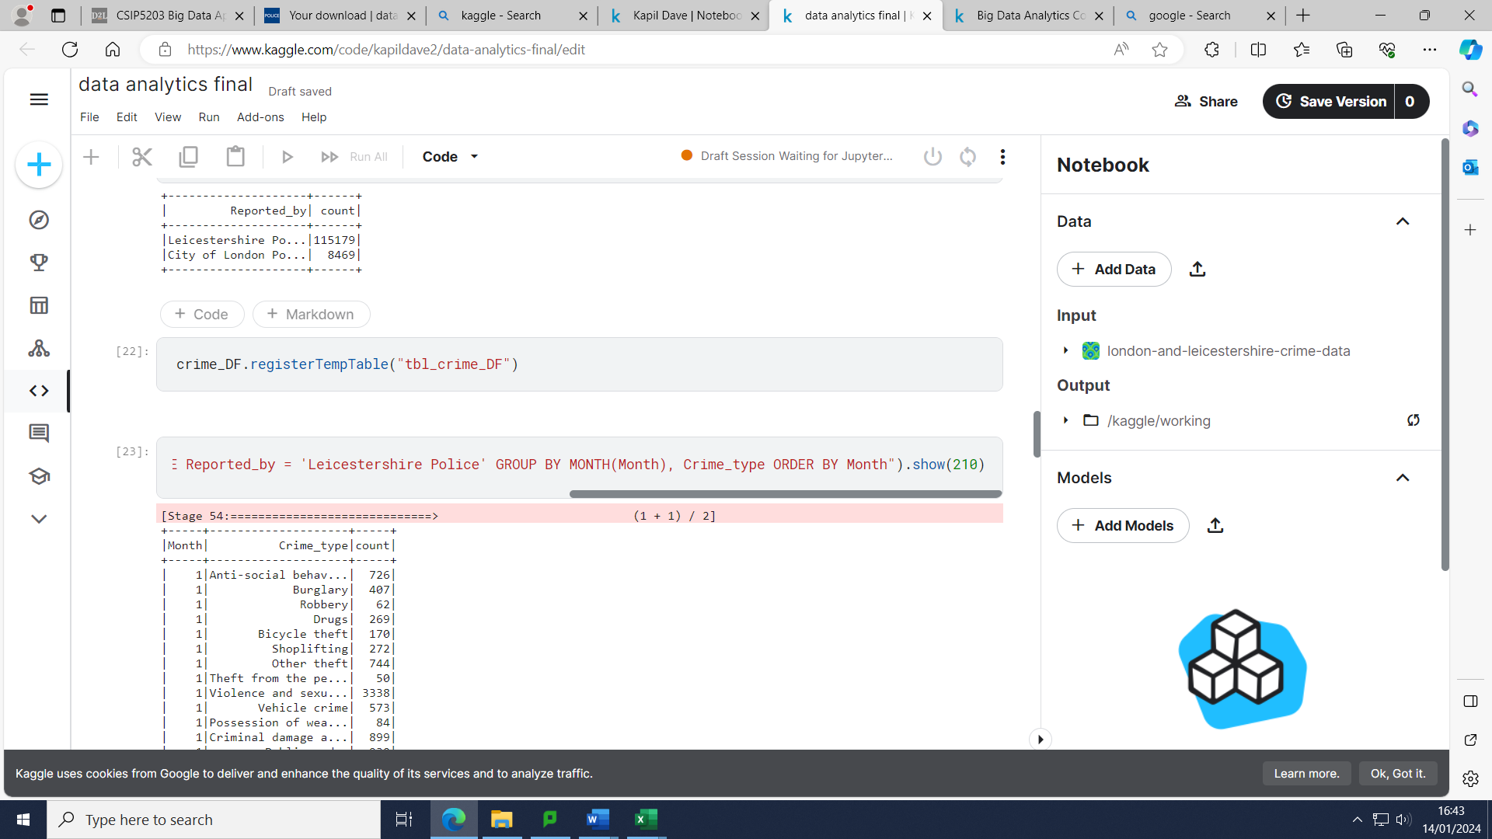

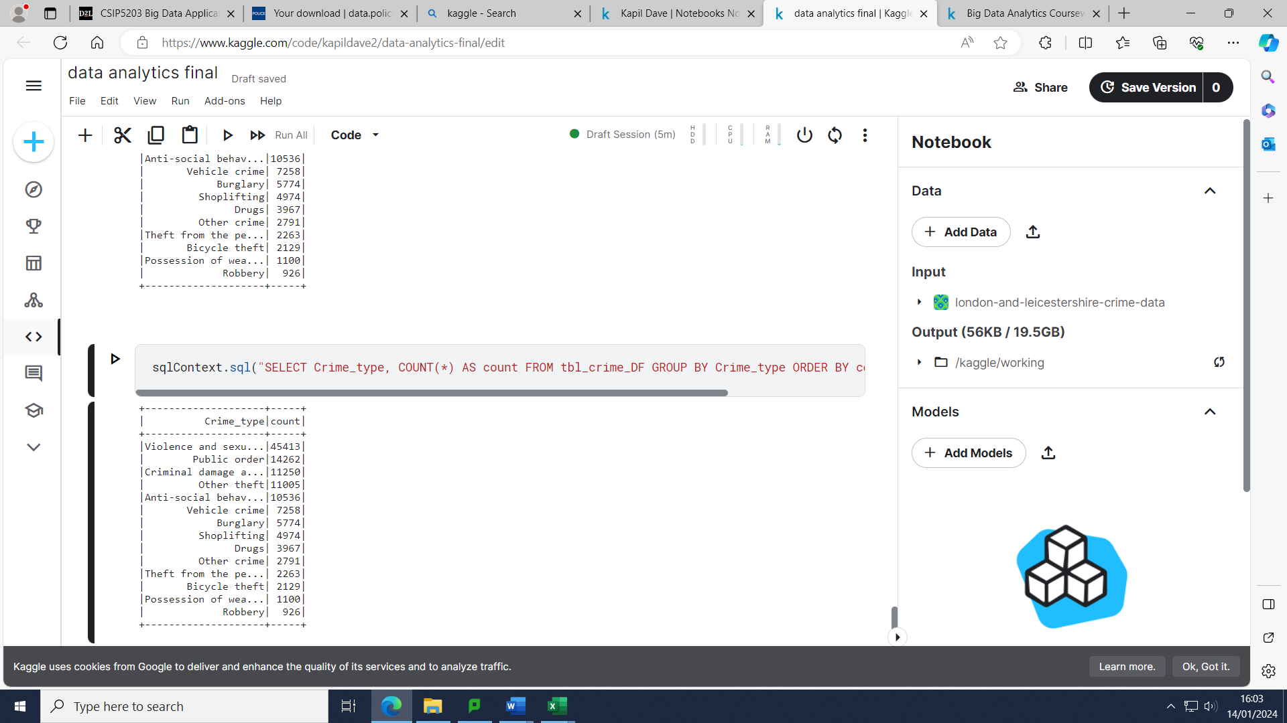

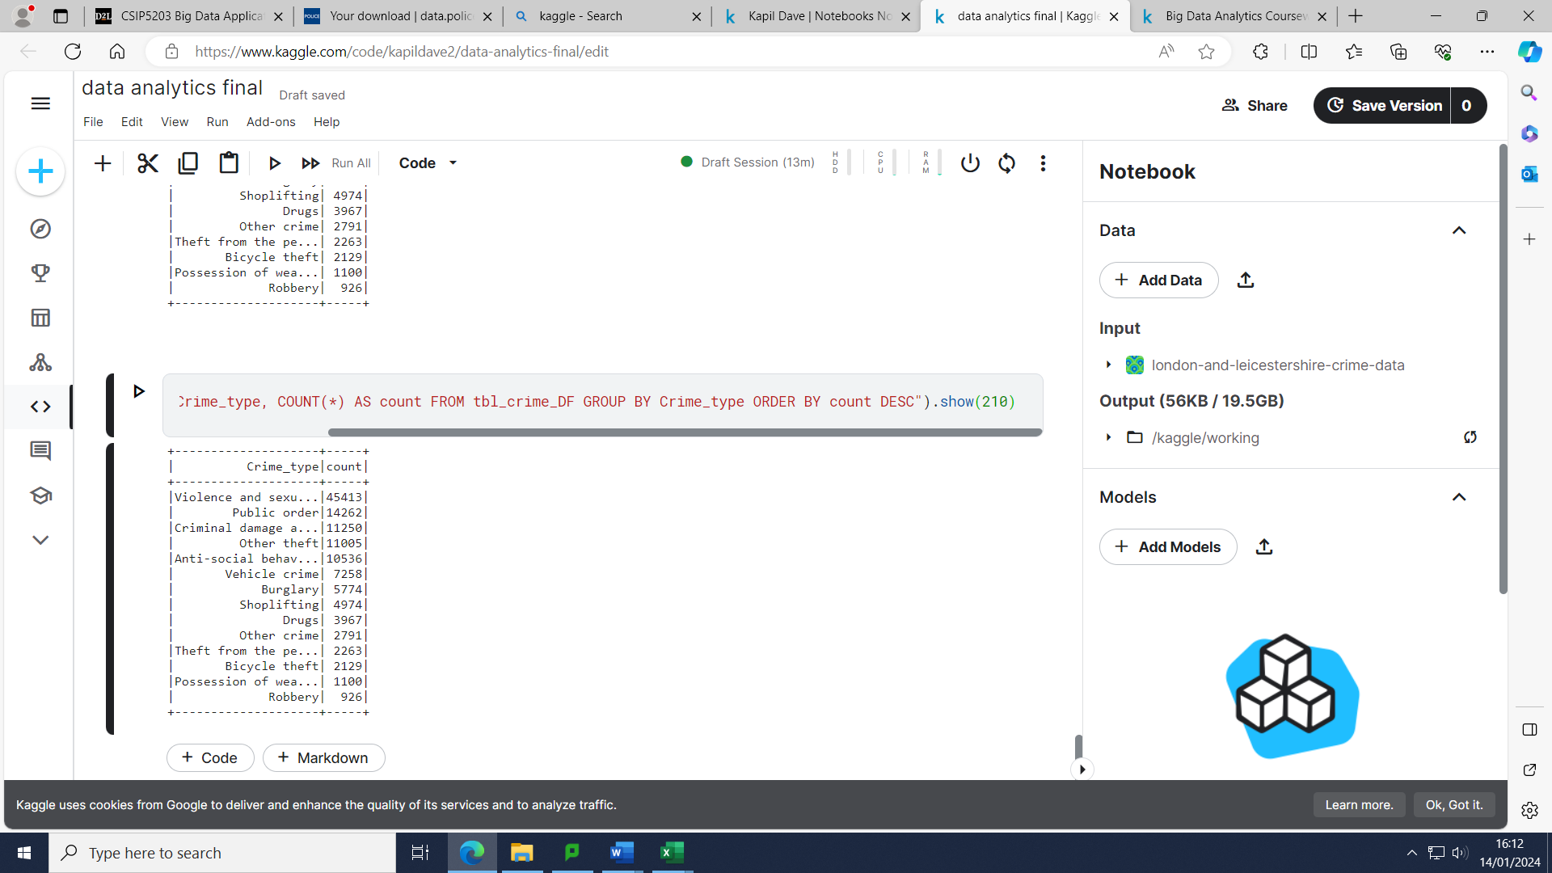

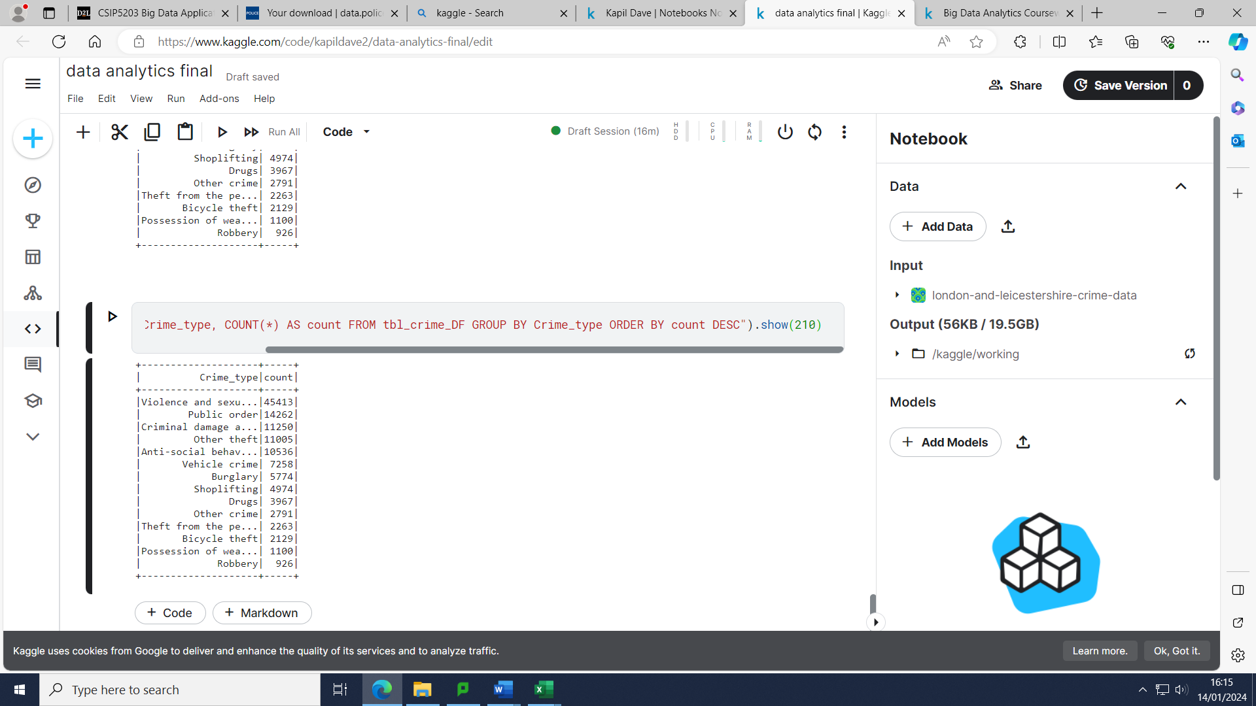

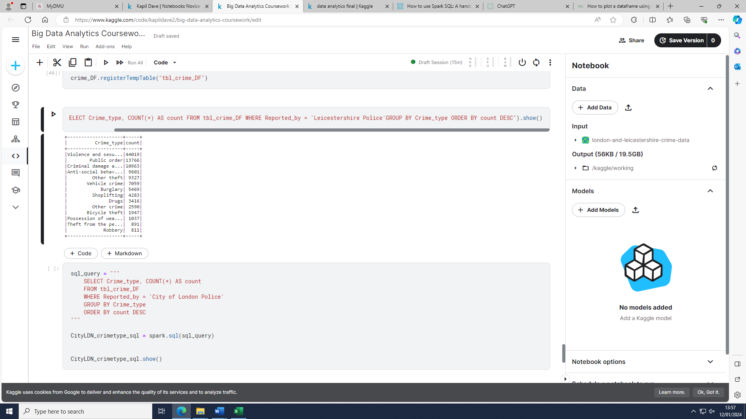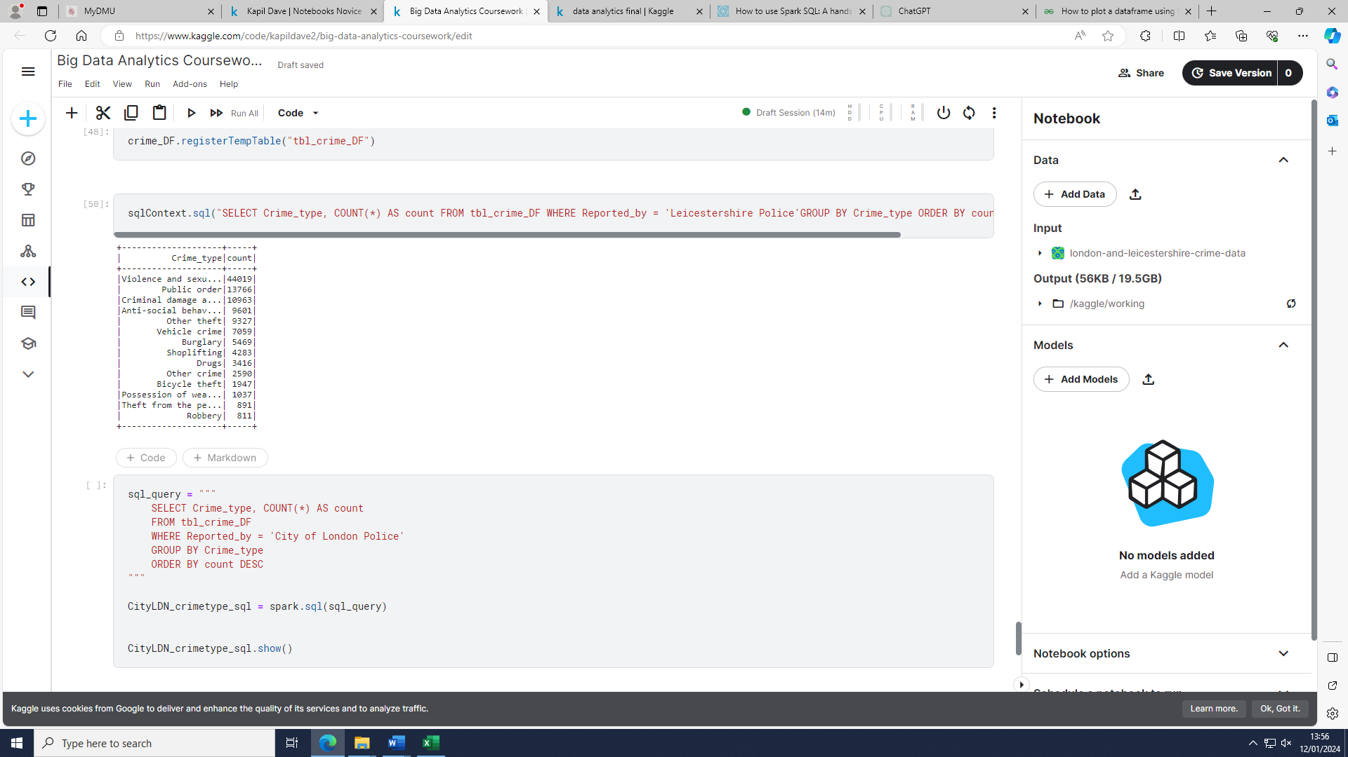

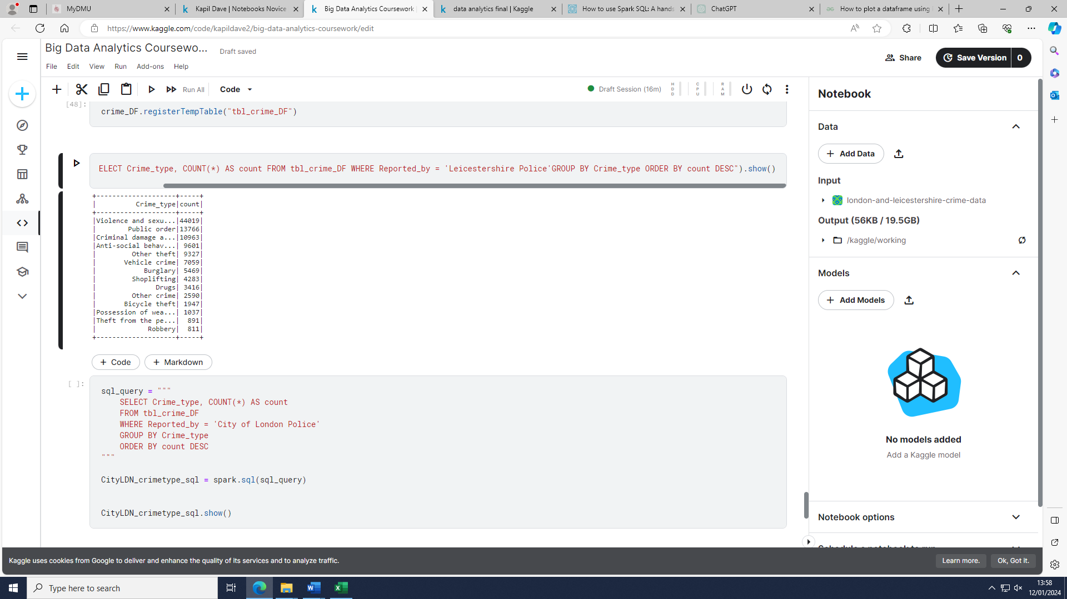

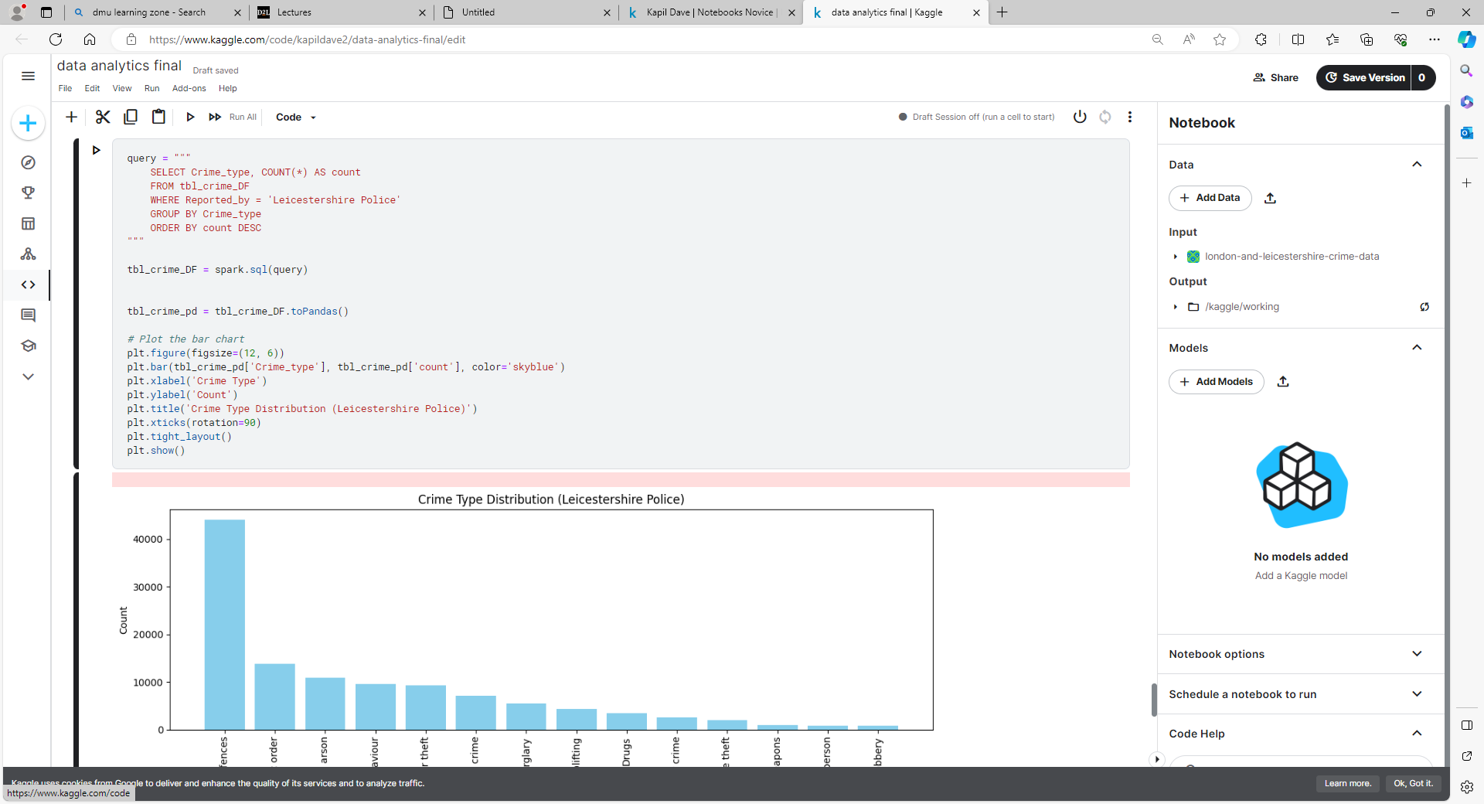

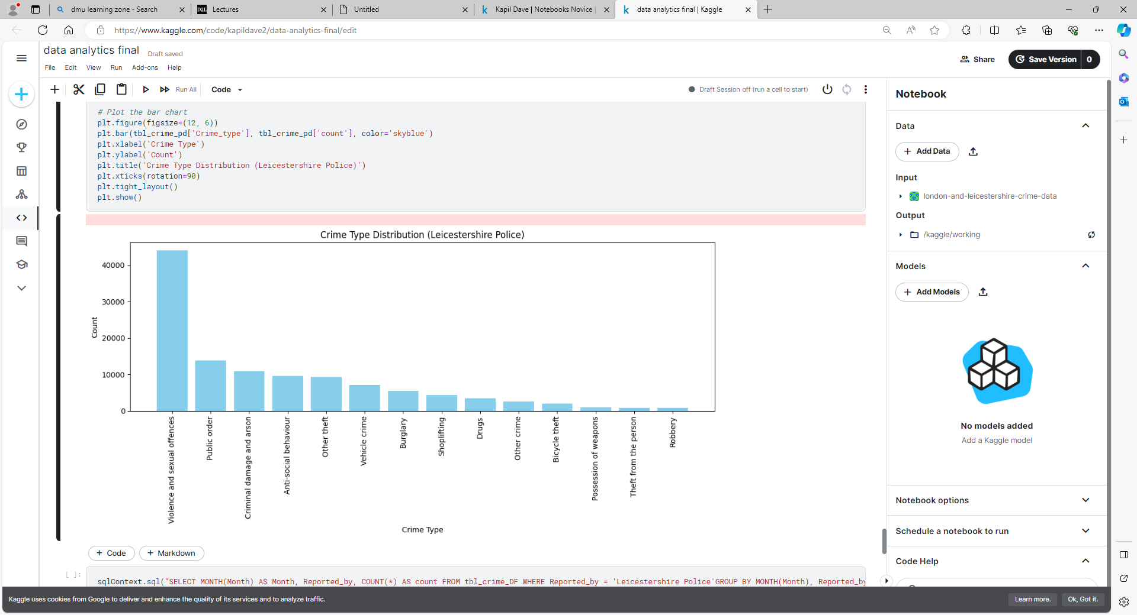

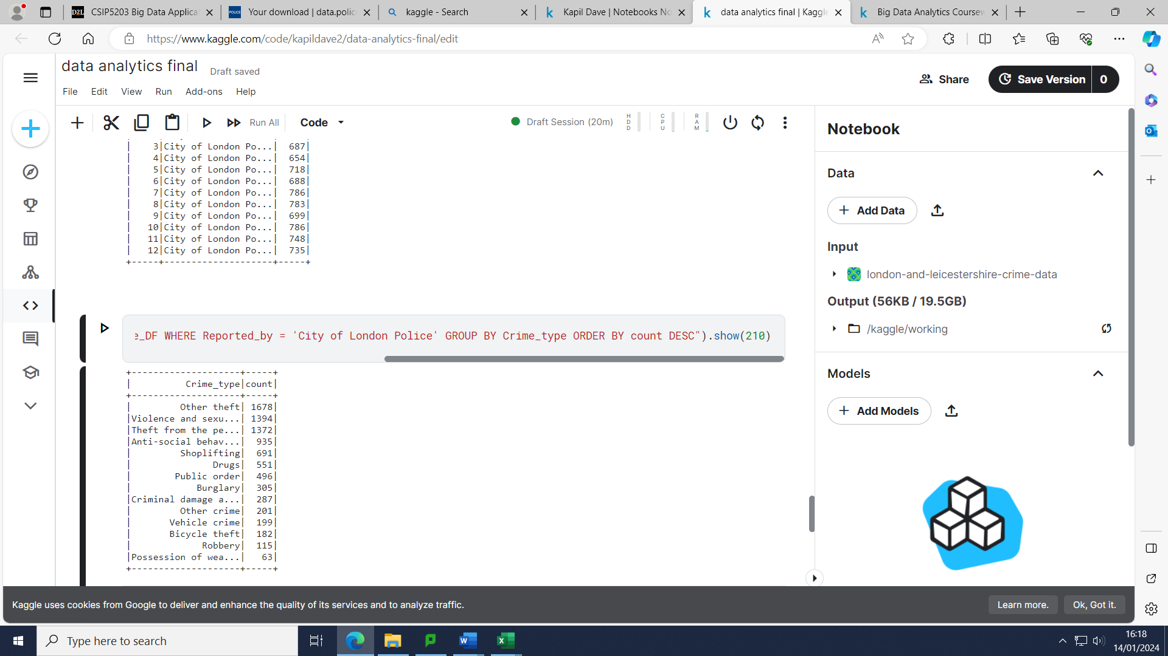

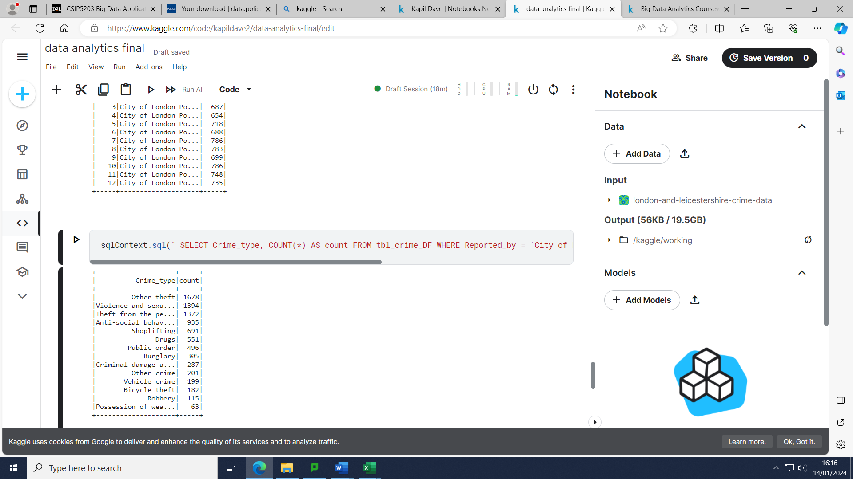

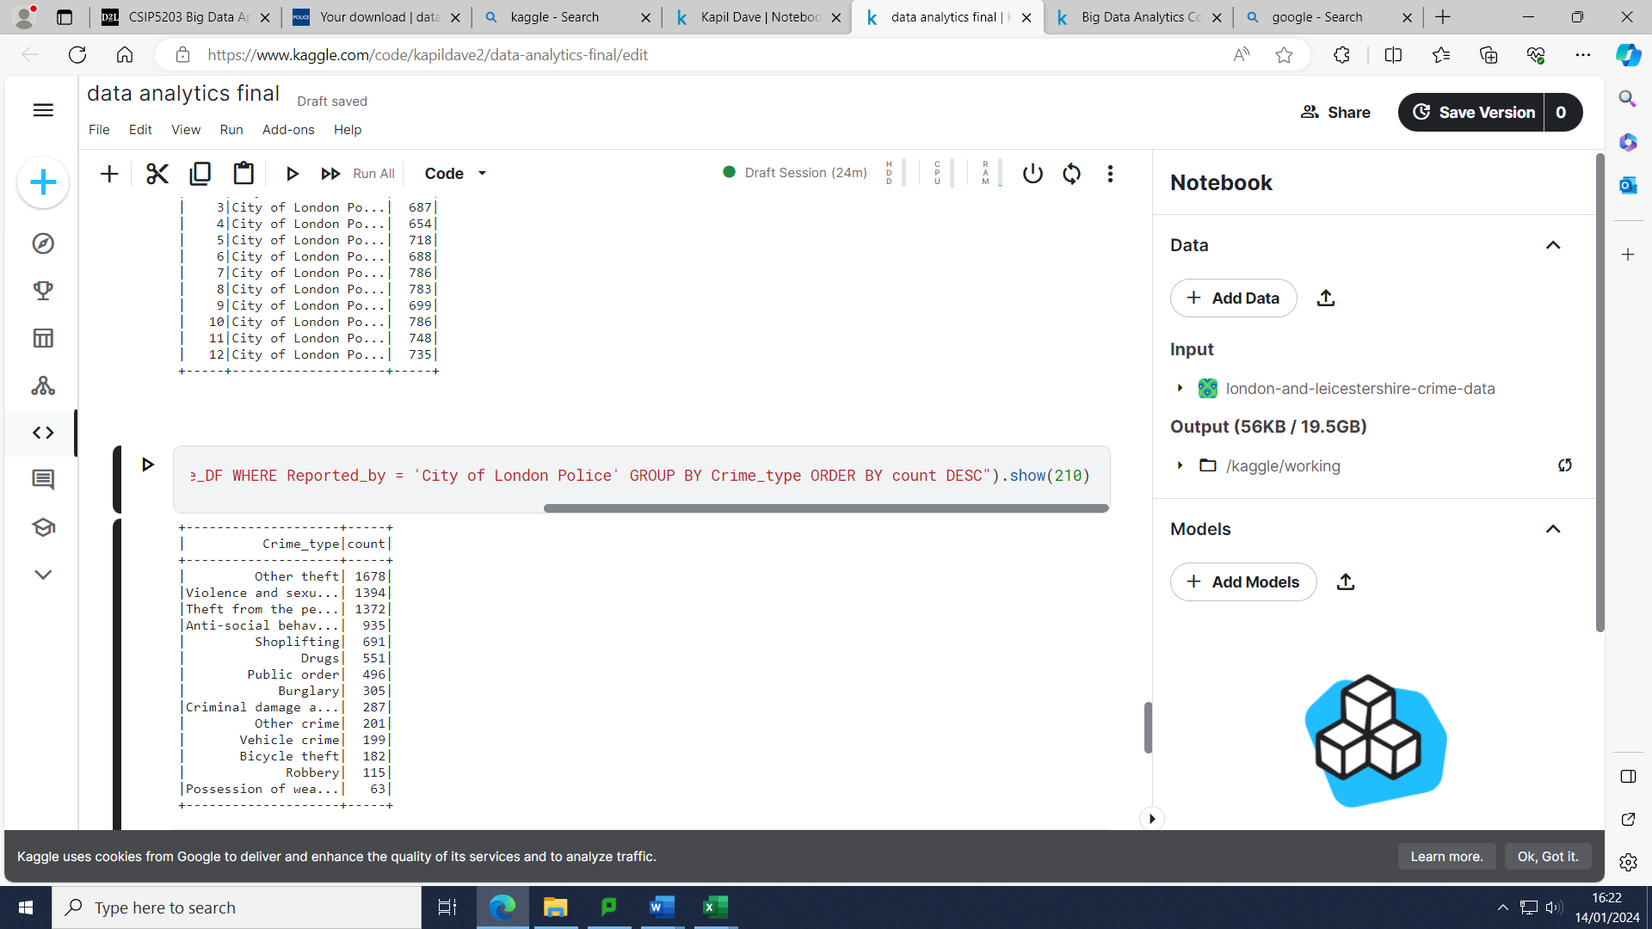

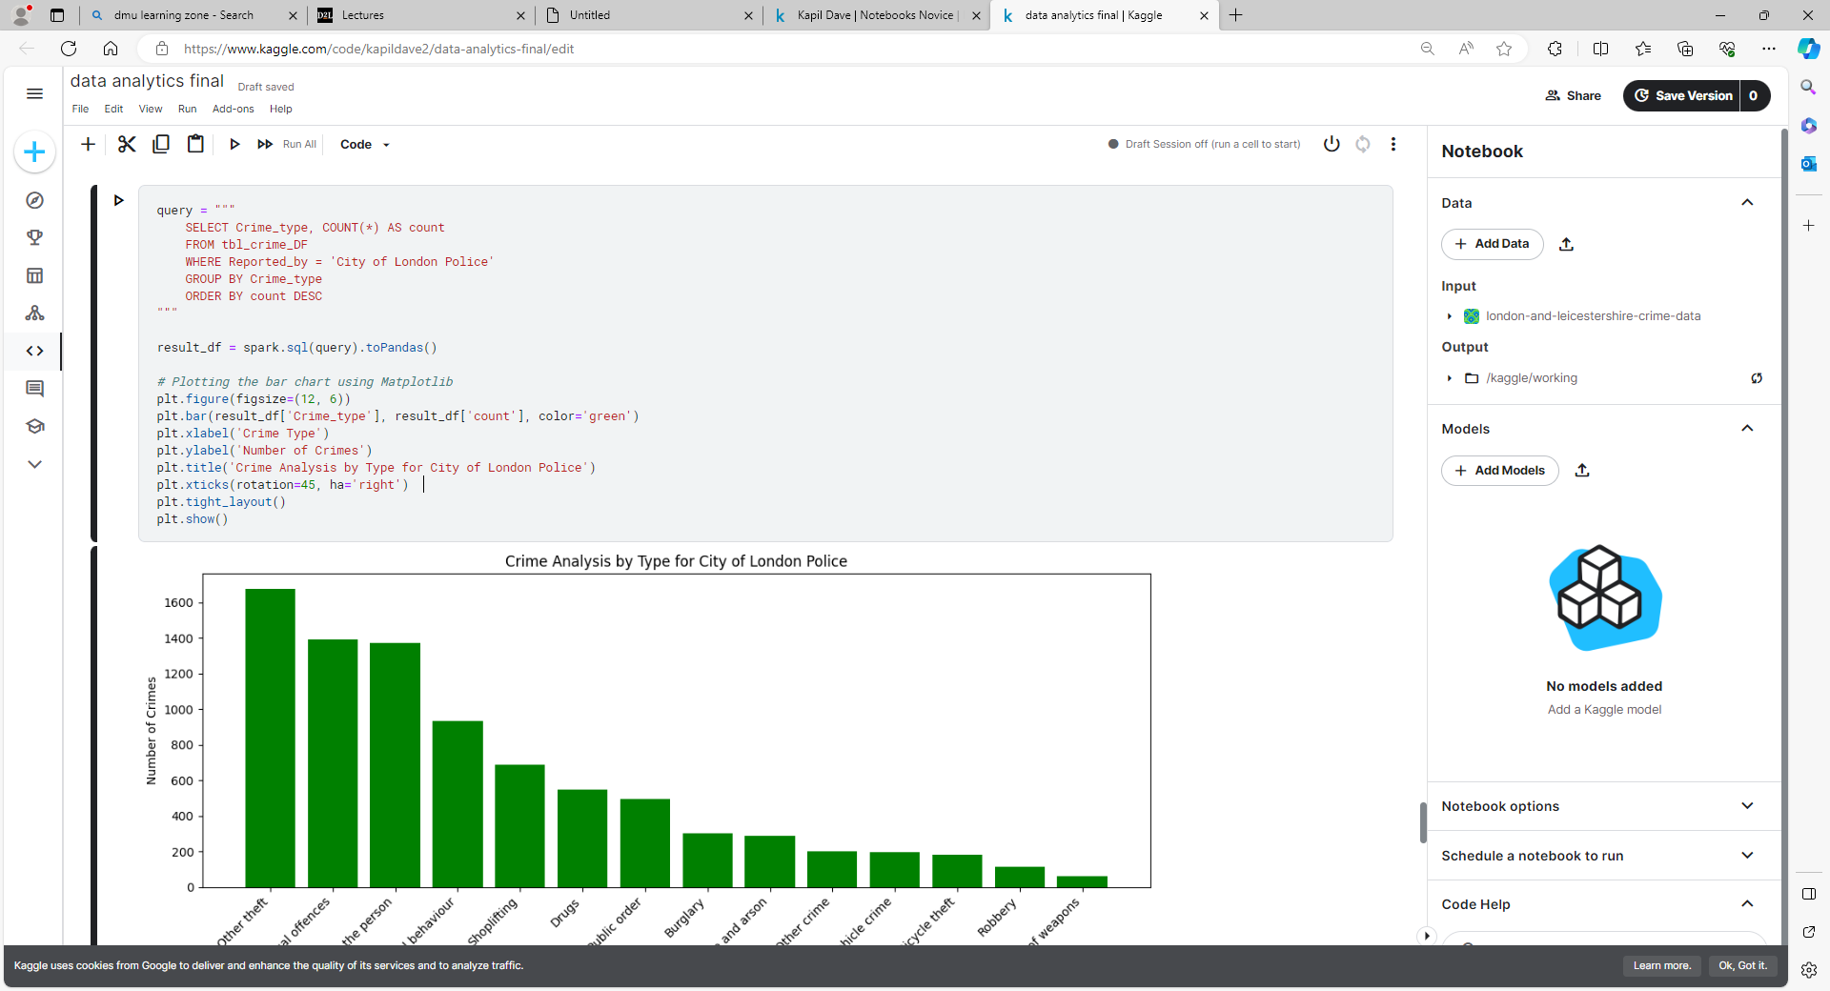

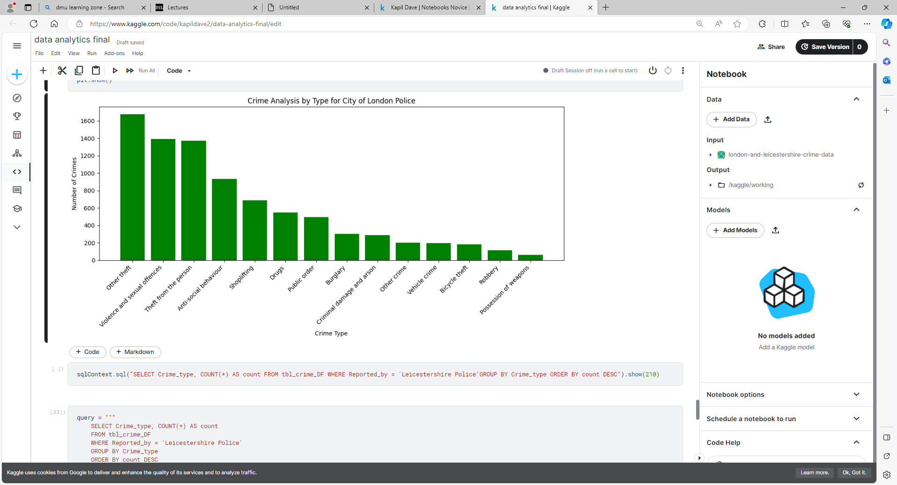

It is evident across both of my chosen areas of analysis that violence and sexual offences were the highest type of crime in the year 2022. Although the overall different types of crime are heavily skewed by the crime which occurred in Leicestershire, ‘violence and sexual offences’ was close to being the type of crime in the city of London alongside ‘theft from the person’. Theft in the city of London would not be surprising considering the household income within this particular area. However, what was fascinating was the fact that 70% of all thefts in London during 2022 were related to mobile phone theft with a phone theft occurring every 6 minutes (Mobile phone stolen every six minutes in London, says Met Police, 2023). In the city of London in particular, during 2022 there was a heavy spike in the amount of mobile phone theft with there being a record of 148 phones stolen in July 2022. This predominantly occurs when visitors are looking to seek directions or hire rides. For comparison’s sake in July of 2023, there were only 44 mobile phone thefts due to intervention from the police (Police, 2023).

Potential reasons for the amount of crime related to violence and sexual offences being particularly high in Leicestershire during 2022 may be due to the easing of Coronavirus restrictions with there being a greater sense of freedom after the frustration of being stuck within an enclosed environment in the previous 18 months or so which may have led to citizen engaging more deeply in the nightlife culture which would probably lead to them carrying out anti-social behaviour under the influence of Alcohol. In Leicester City where the average crime rate is above Leicestershire's average crime rate with 128 crimes per 1000 people, there was a rise of 7% in these types of offences in 2022 as compared to 2022 which could be explained by the factors mentioned above (Anon, 2023). Another explanation for the high amount of violence and sexual offences in Leicestershire is that over the years victims have gained confidence in reporting such offences according to Detective Chief Inspector Lucy Batchelor (Moorhouse, 2023).





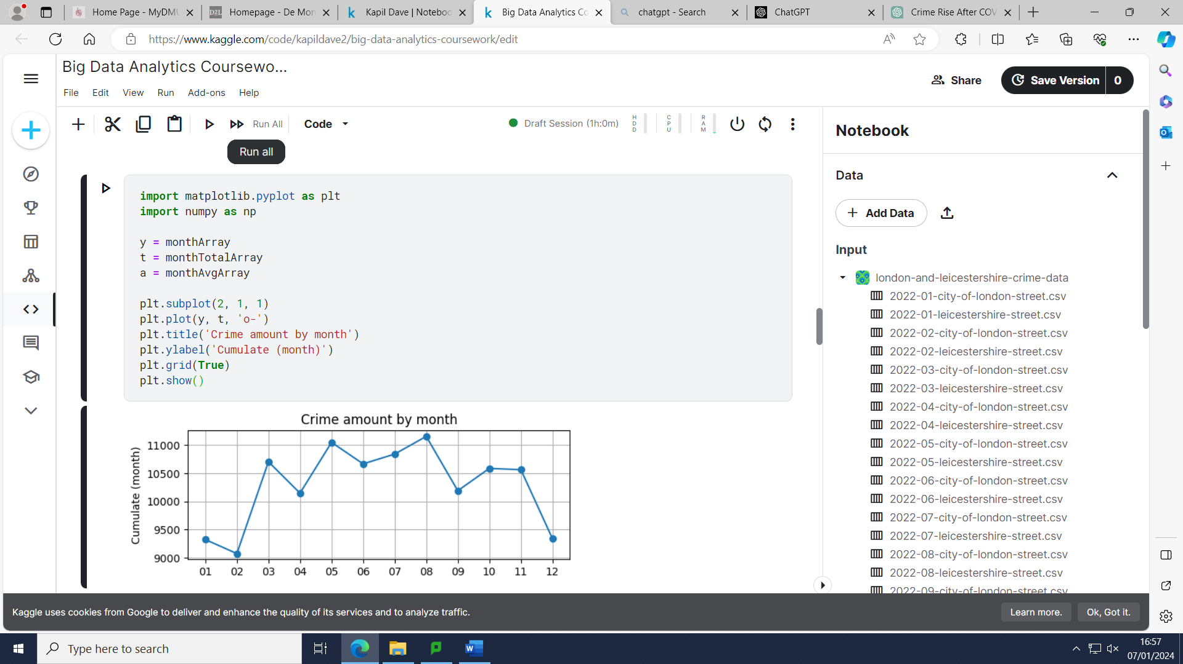



If we observe the crime per month in 2022, we can clearly notice that the crime per month seems to be the highest during the summer with a sharp rise from February 2022 to March 2022. A few factors which may have contributed towards the higher amount of crime during the summer of 2022 with there being a drastic increase in crimes in March 2022 are that the COVID-19 restrictions were fully eased on the 24th February 2022 and also with the weather becoming warmer there would be more tourism and the general public more inclined to stay outdoors (Aid, 2022).

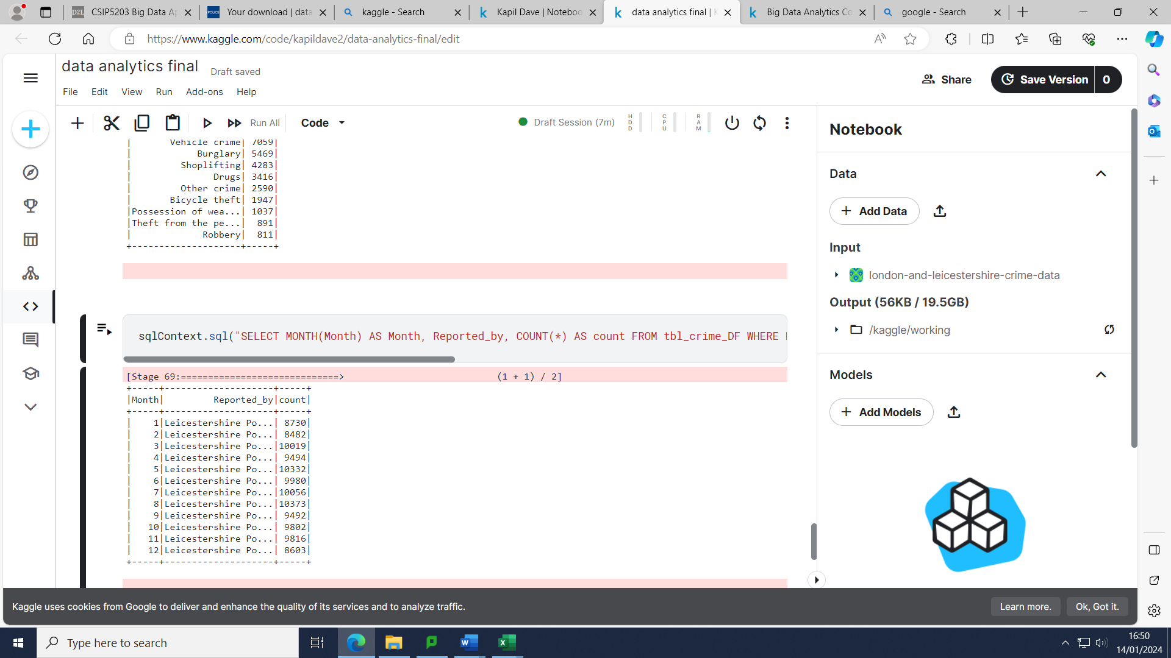

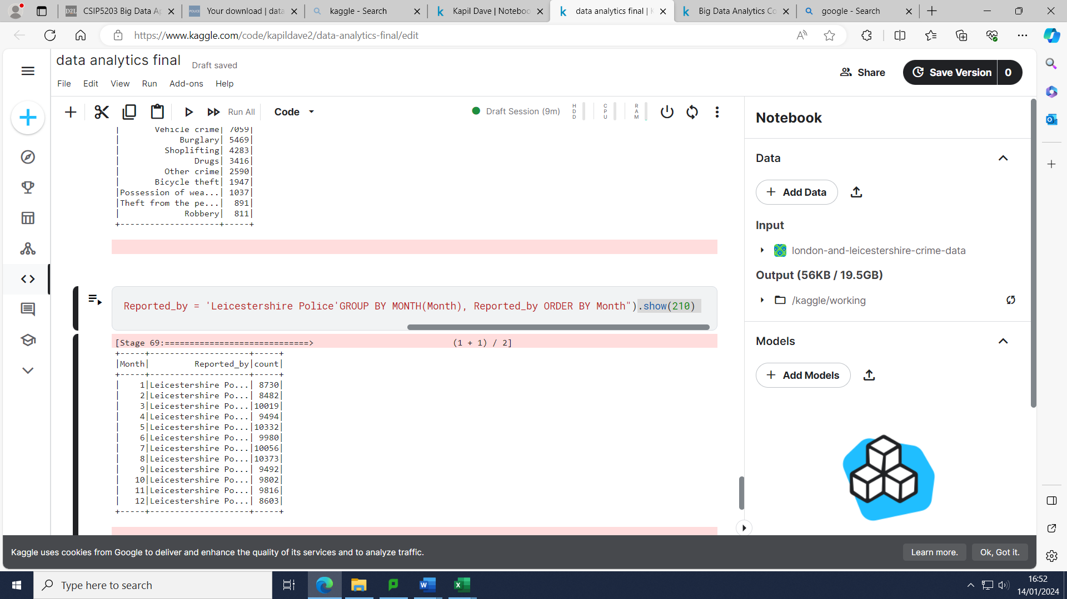

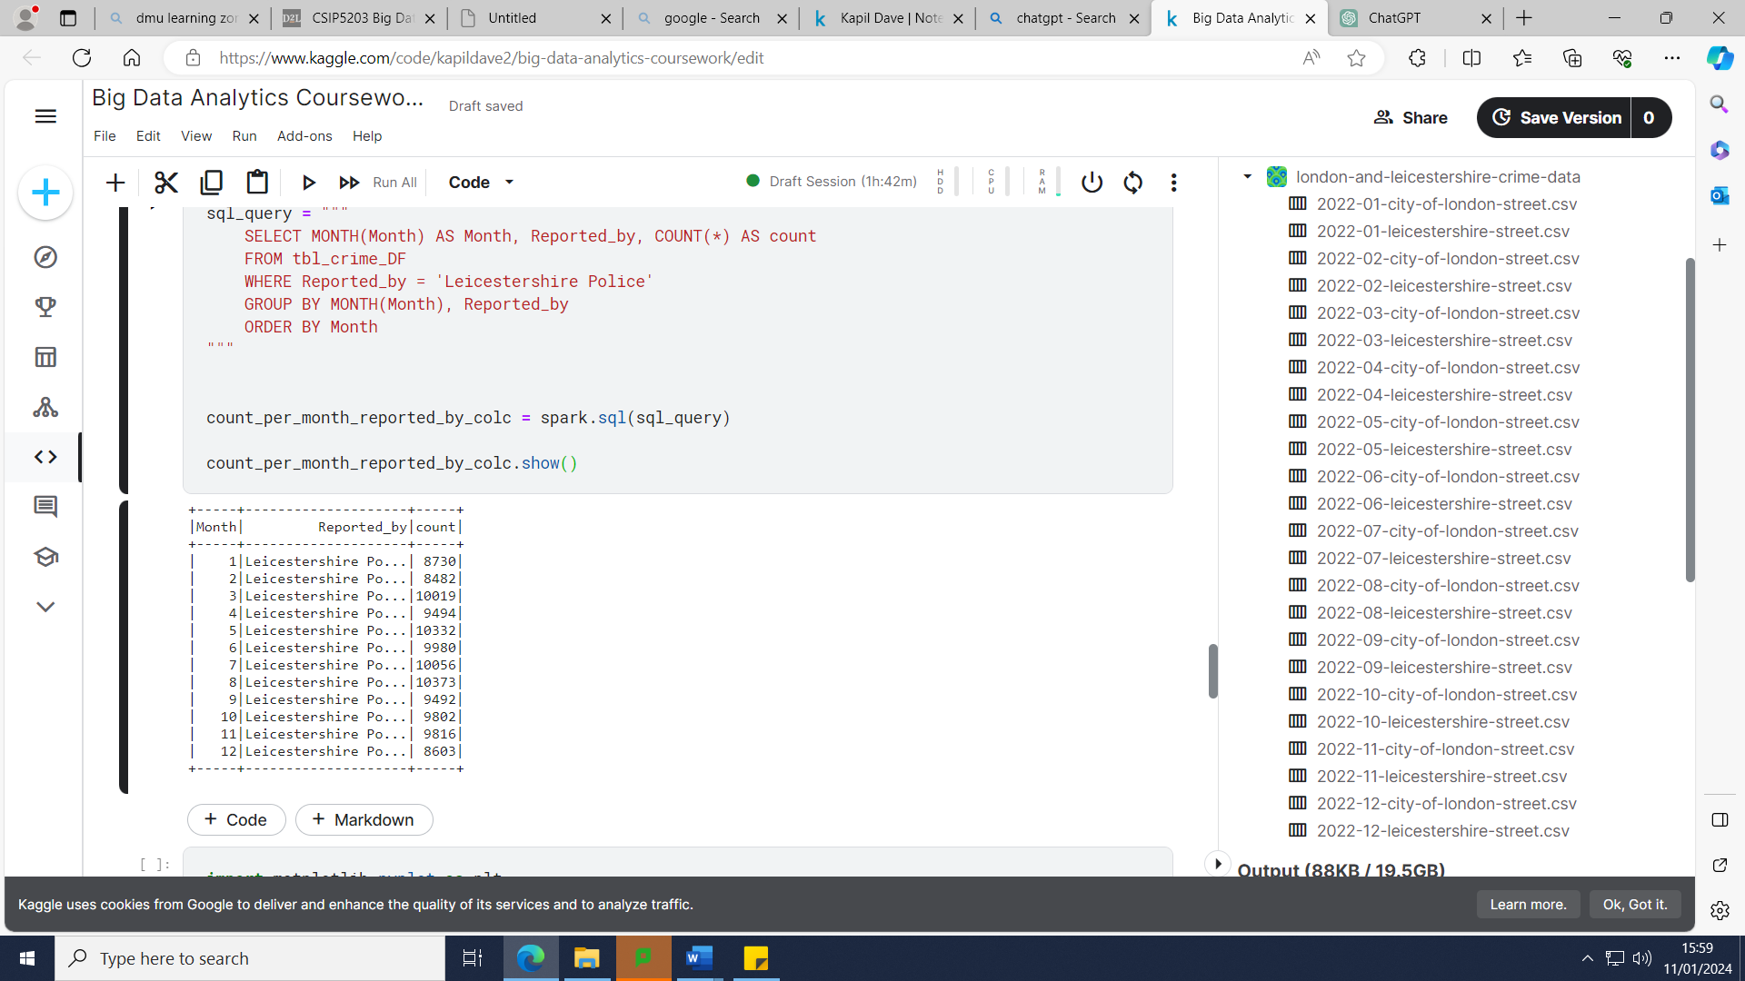

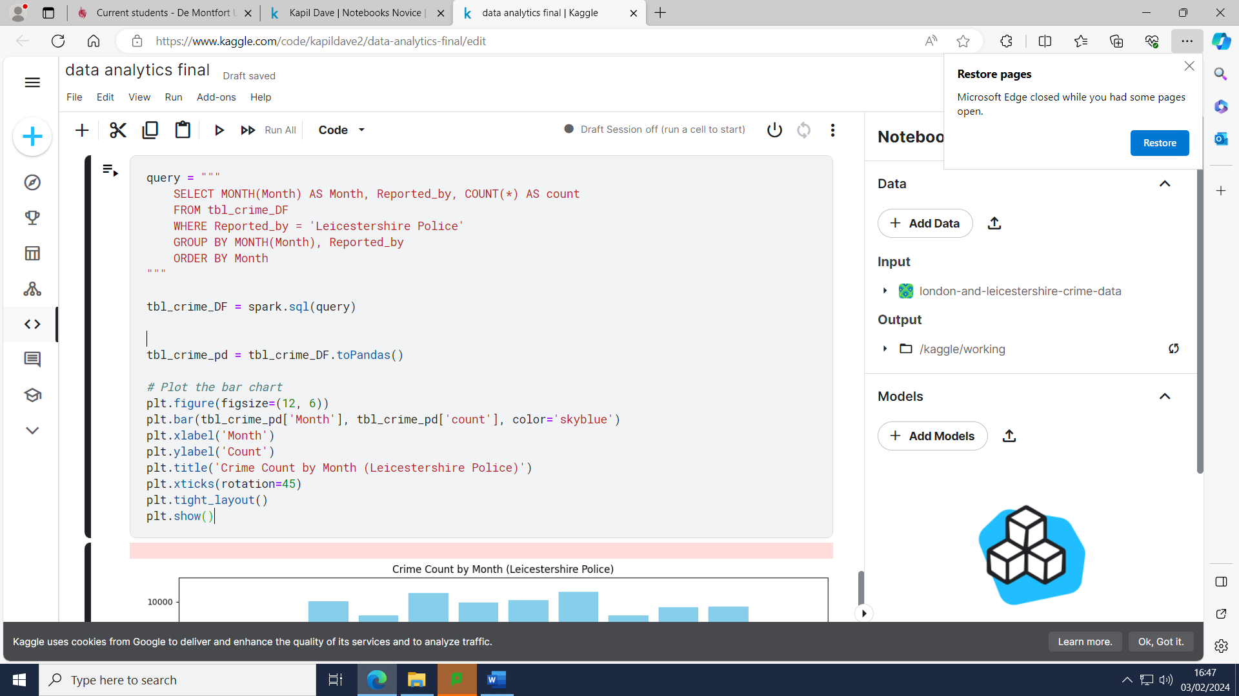

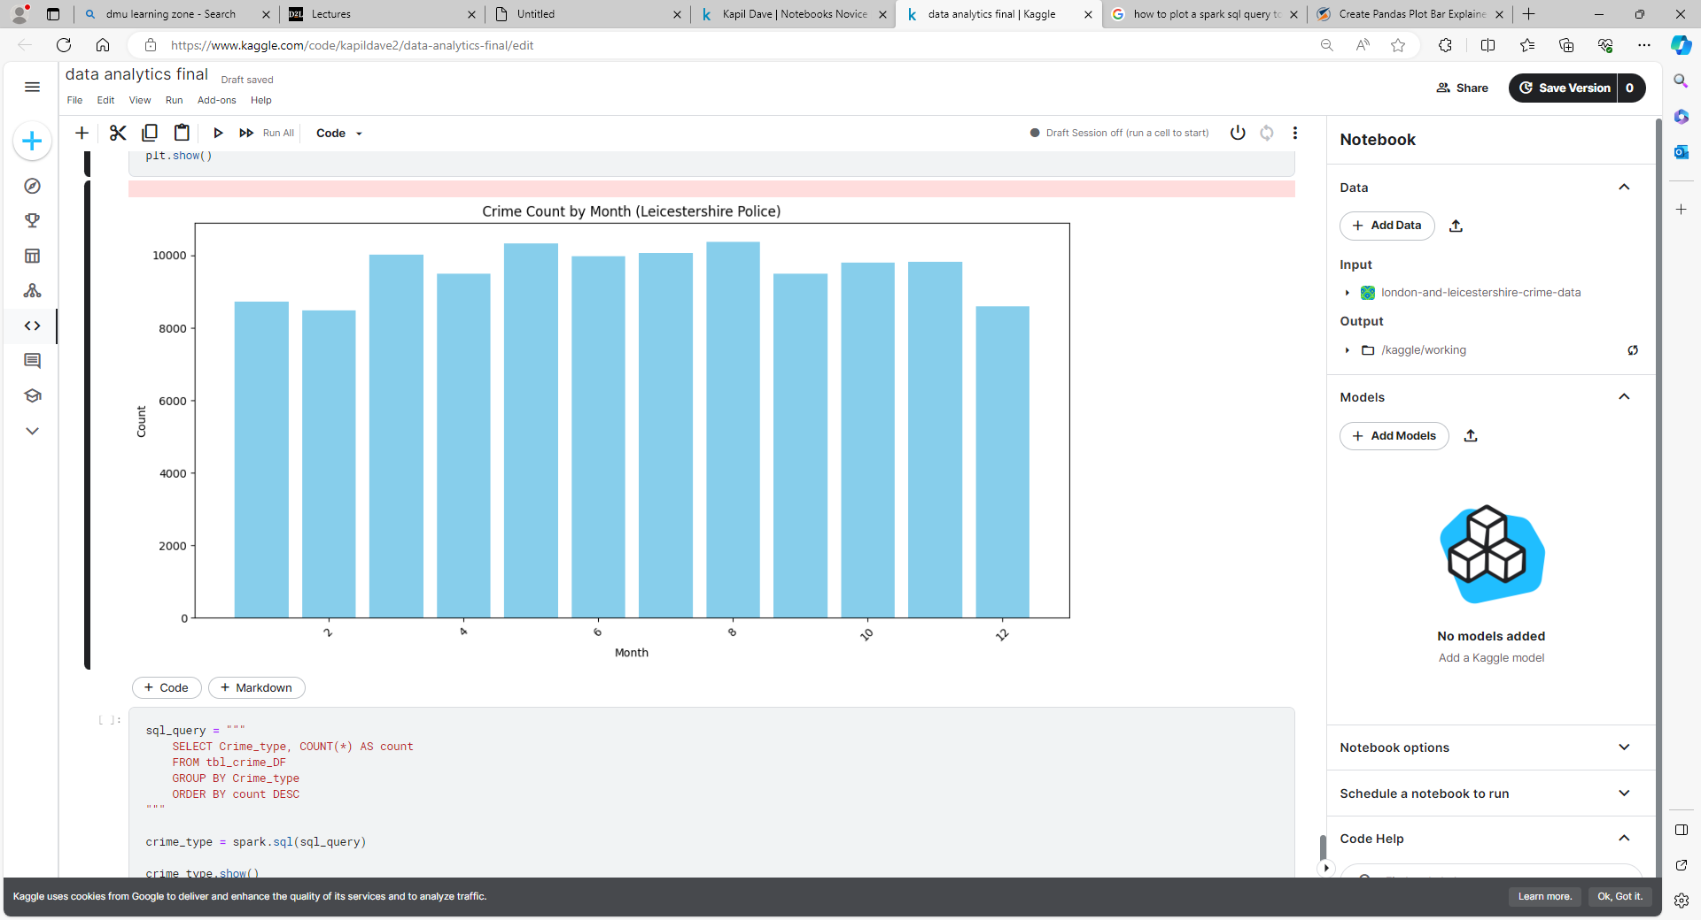

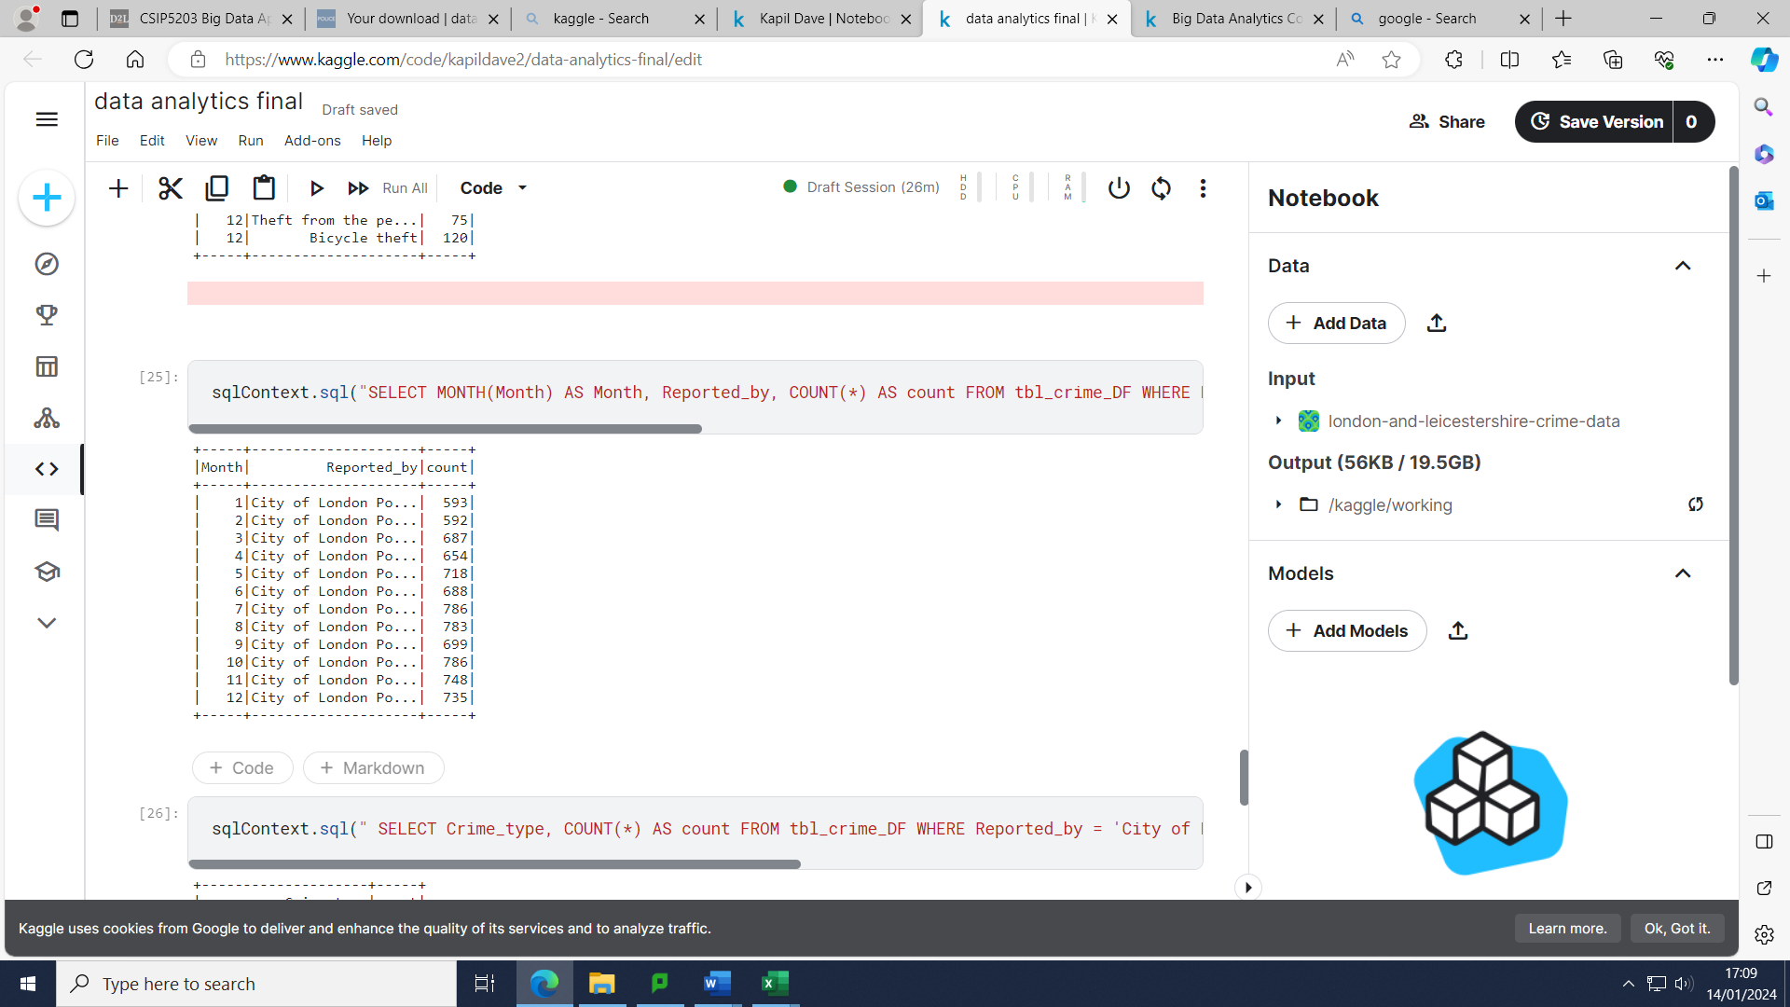

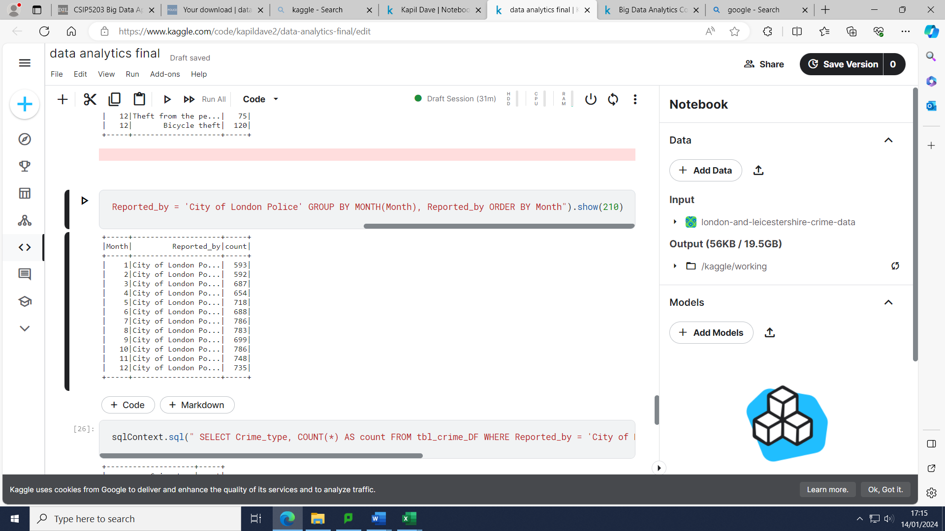

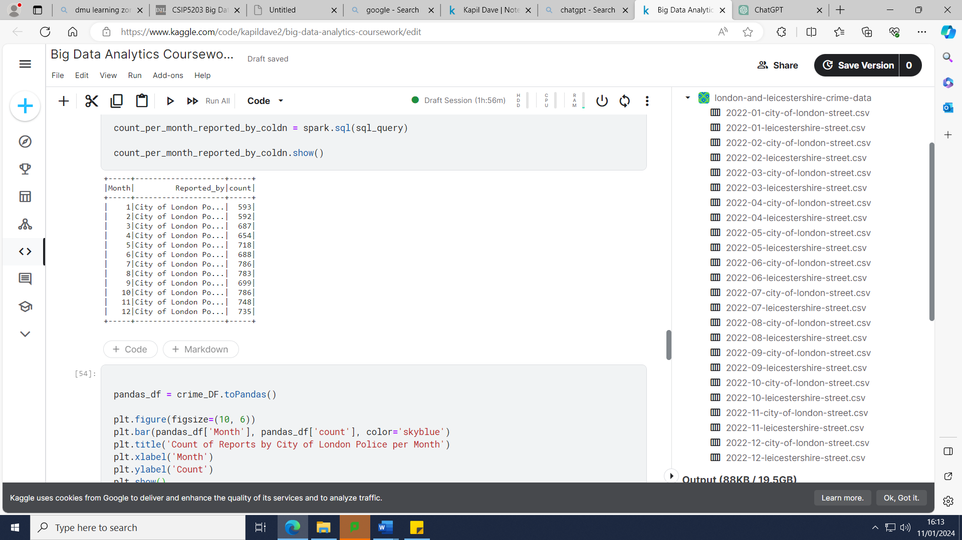

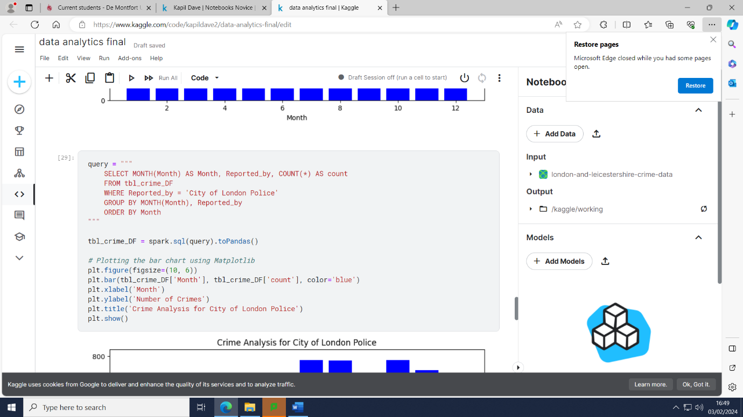

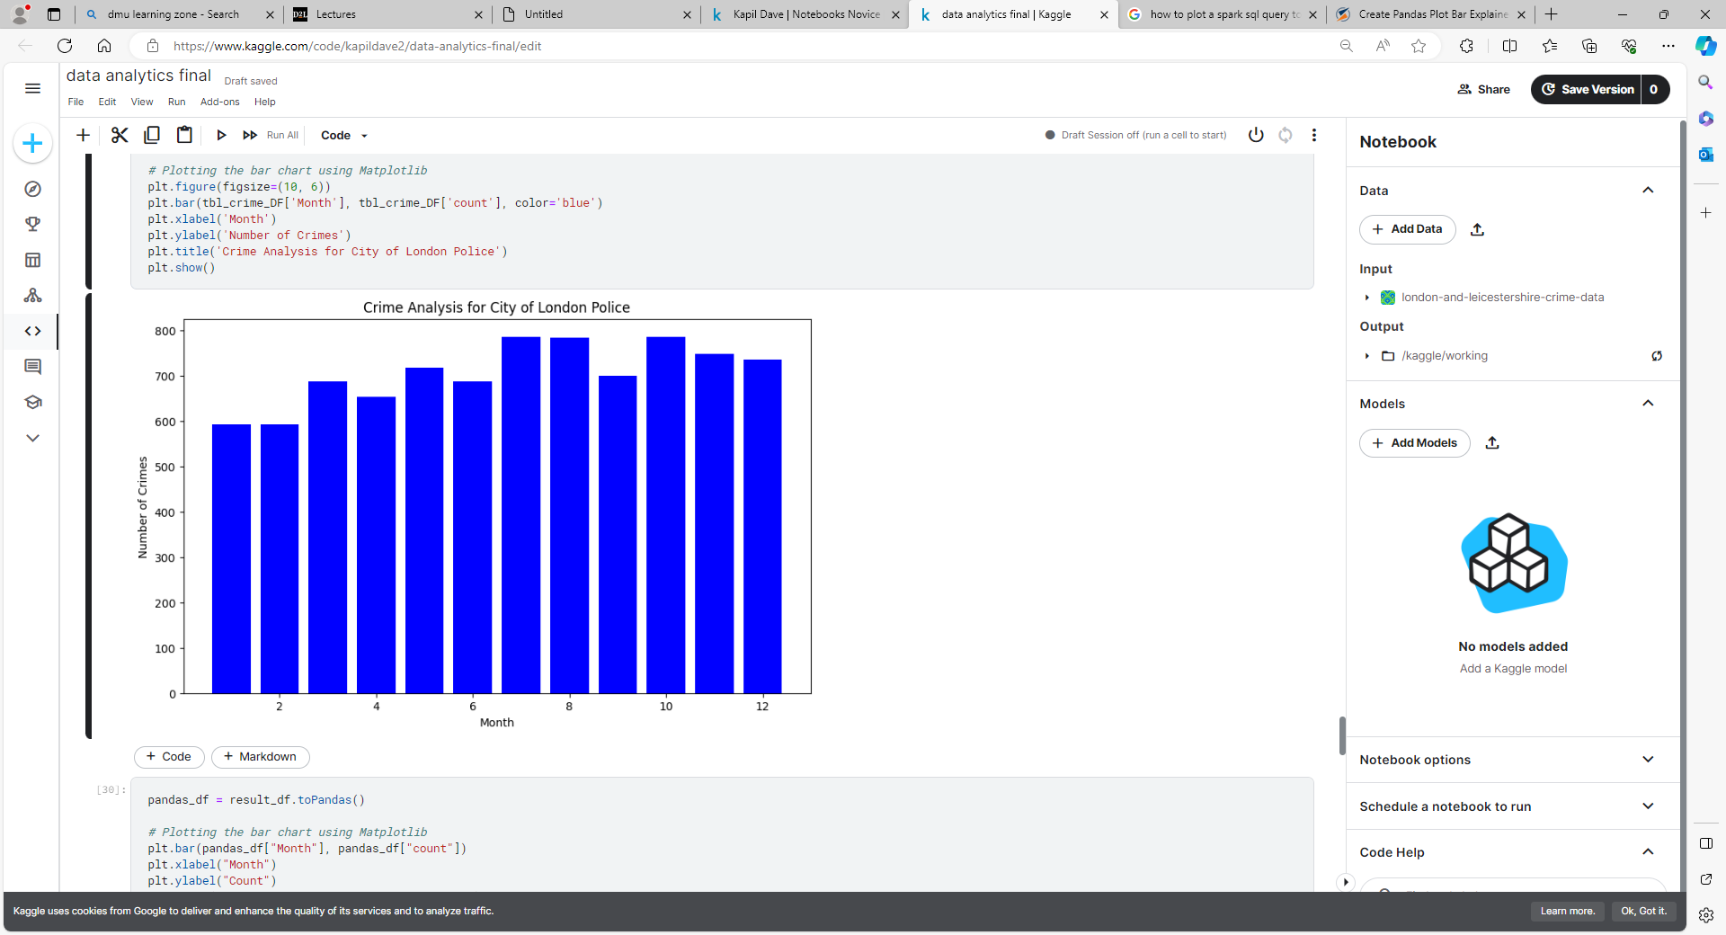

If we look at both areas individually, we can see a trend where the crime rate seems to be higher during the summer season with July and August seeming to have the peak months with the most amount of crime. Across Leicestershire, the easing of the COVID-19 restrictions seems to have had a clear effect on crime count with there being an 18.12% increase in crime count from February to March 2022. There was a similar amount of increase in crime count in the City of London with a 16.04% increase. The record amount of mobile phone thefts in the City of London as mentioned earlier may have contributed towards July being the month with the highest crime count. According to data from the London Metropolitan Police in between April 2010 and June 2018, violent crime was on average 14% higher when the temperature was above 20 Degrees Celsius and harassment and weapon possession were each 16% higher. According to scientists an explanation for this is because heat triggers a particular physiological response which tends to make people angrier and more impatient. However, there is also a correlation between a reduction in burglaries when temperatures seem to increase. When the temperature was above 20 degrees there were around 20% fewer burglaries relative to when the temperature was below 10 degrees. A met police states that the houses remain in darkness for longer in the evenings which will make it more attractive to burglars during the winter period. He also supports my hypothesis of how greater amounts of interactions in outdoor spaces during the summer will lead to more conflicts and violence (team, 2018).

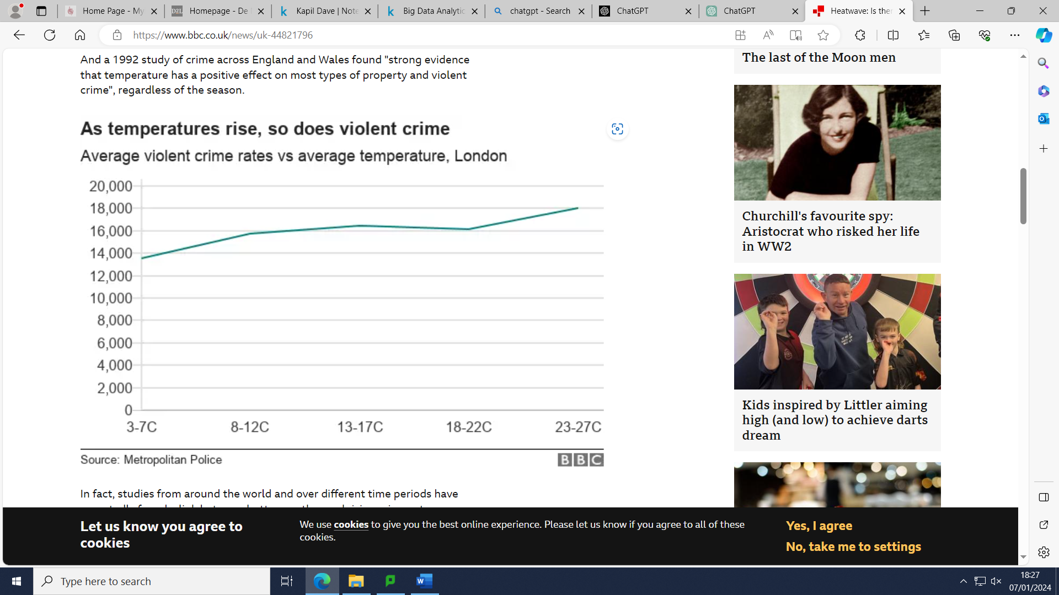

(team, 2018).

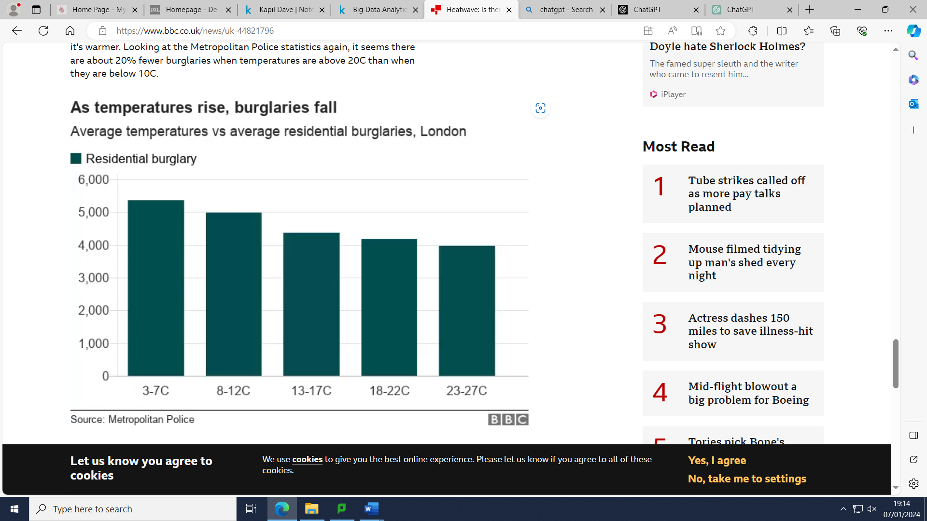

(team, 2018).

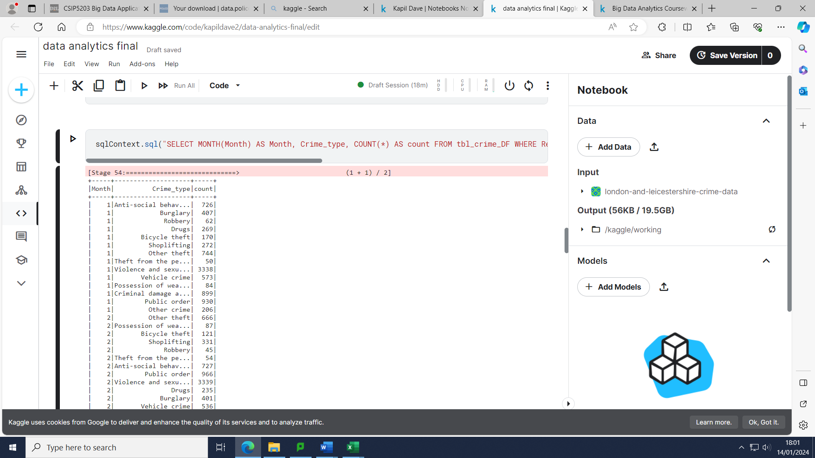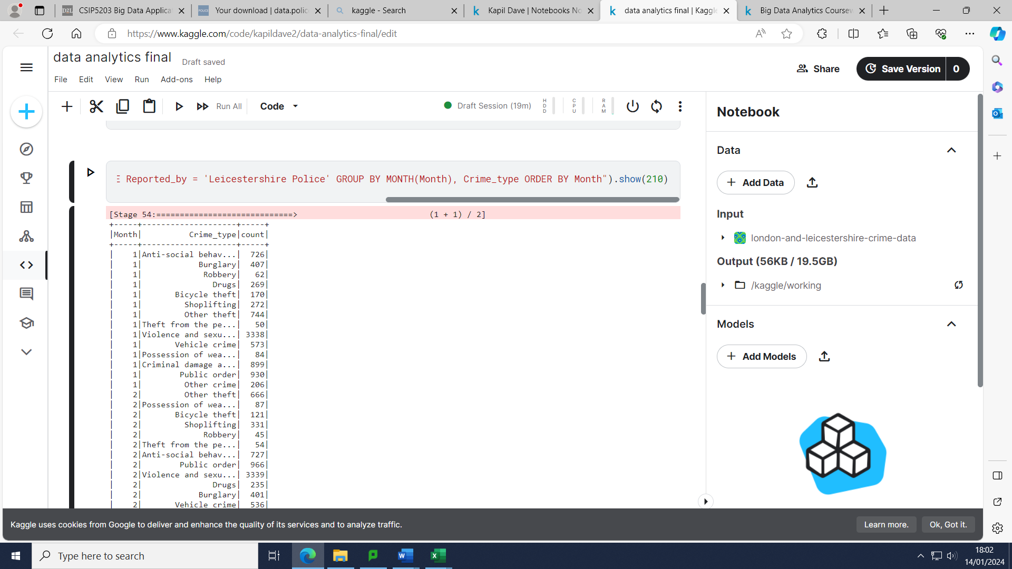

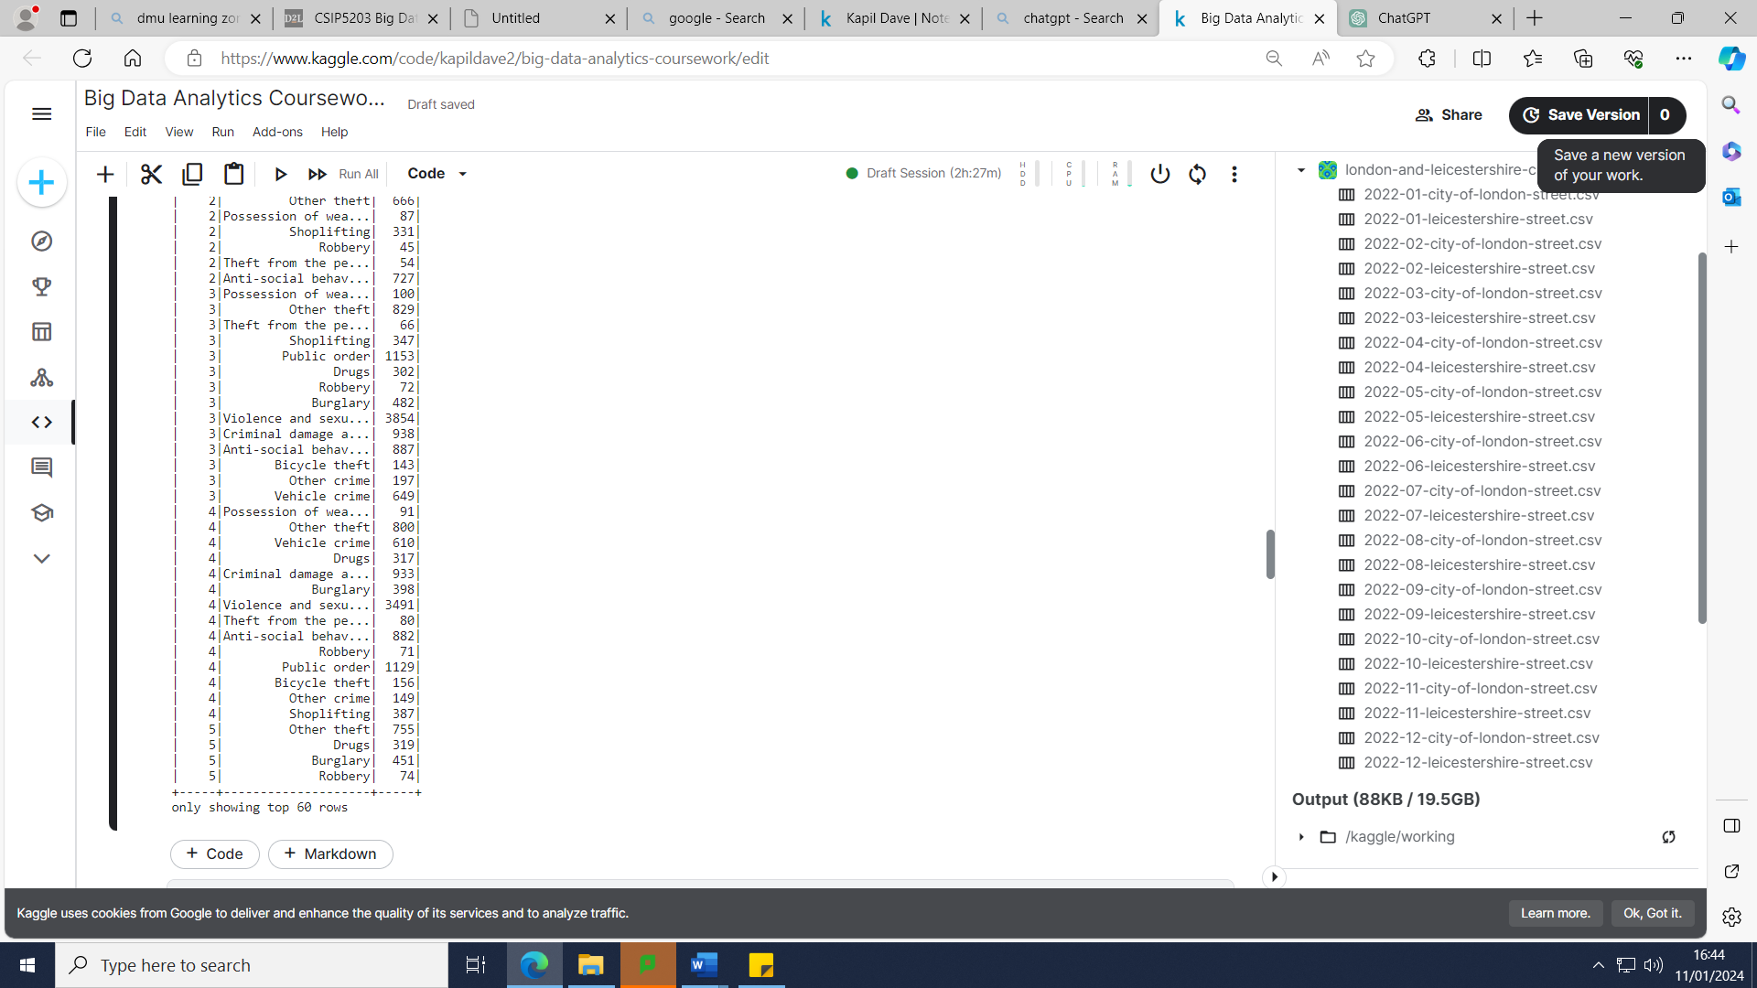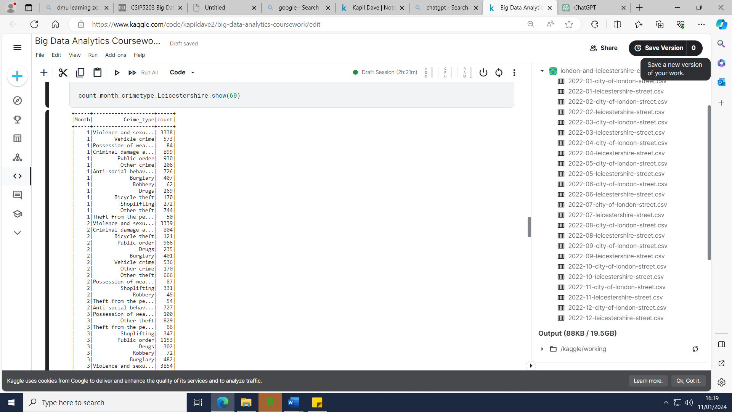



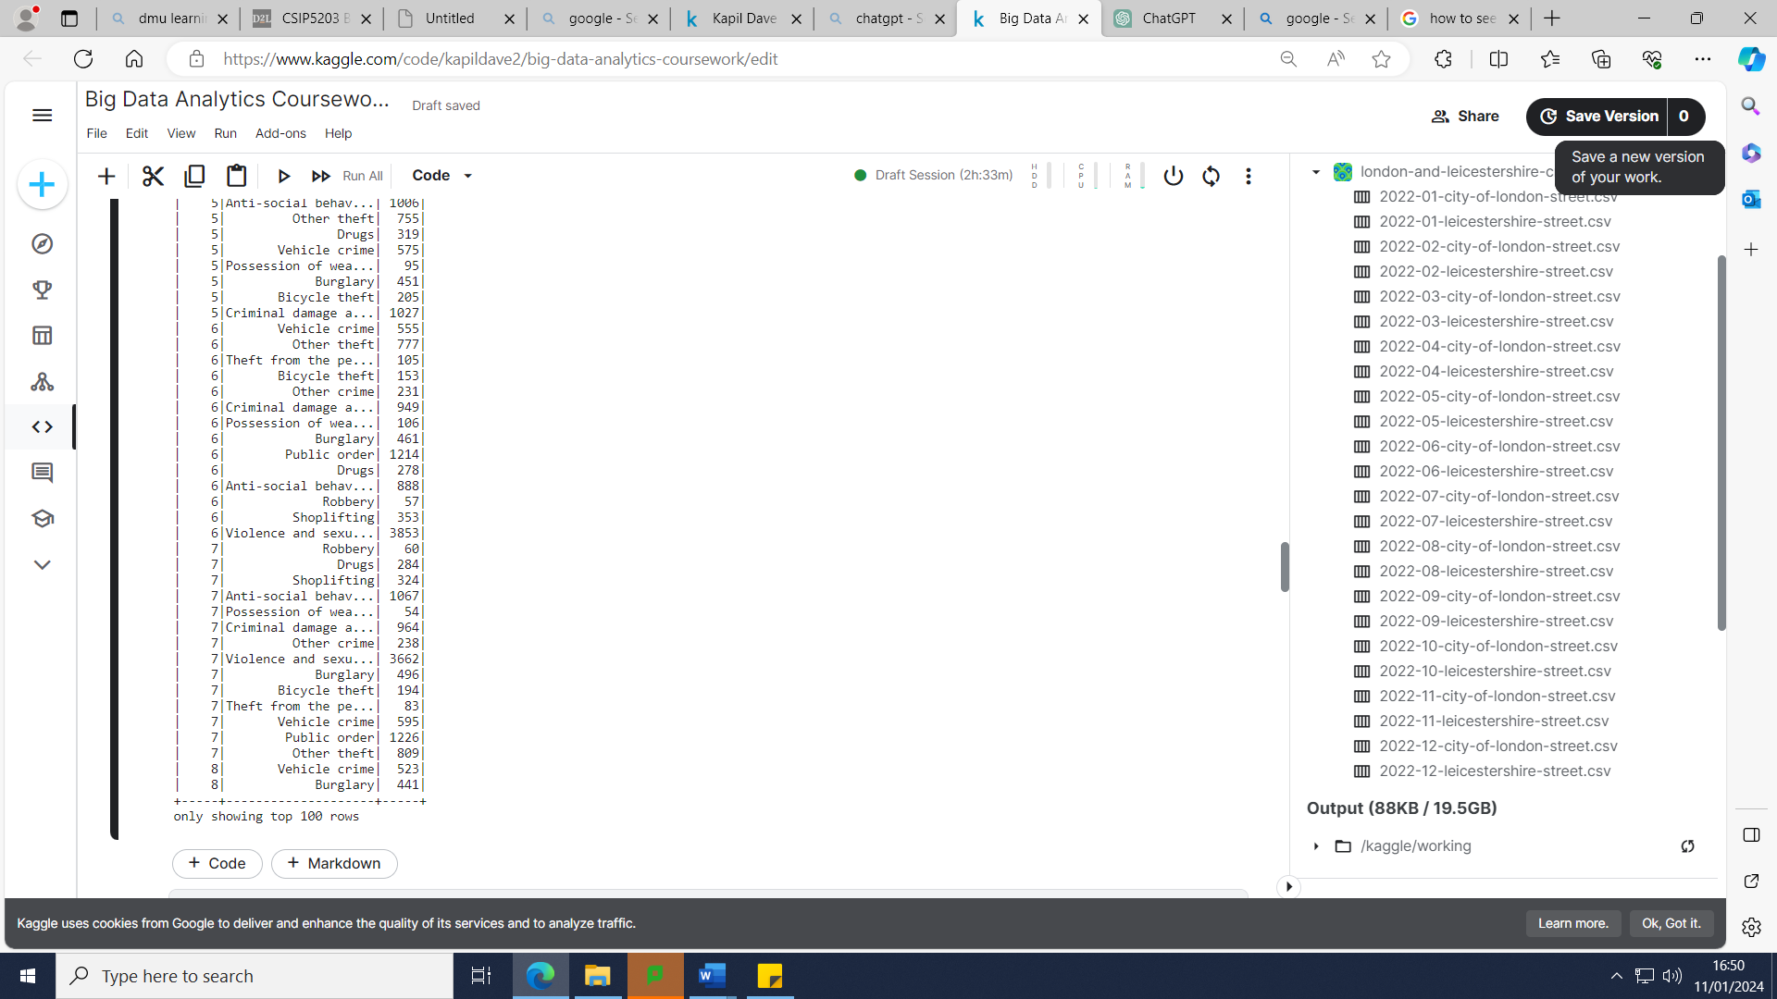

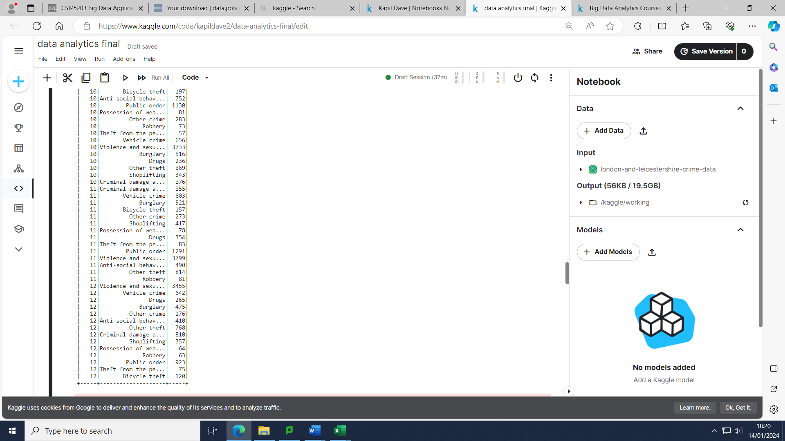

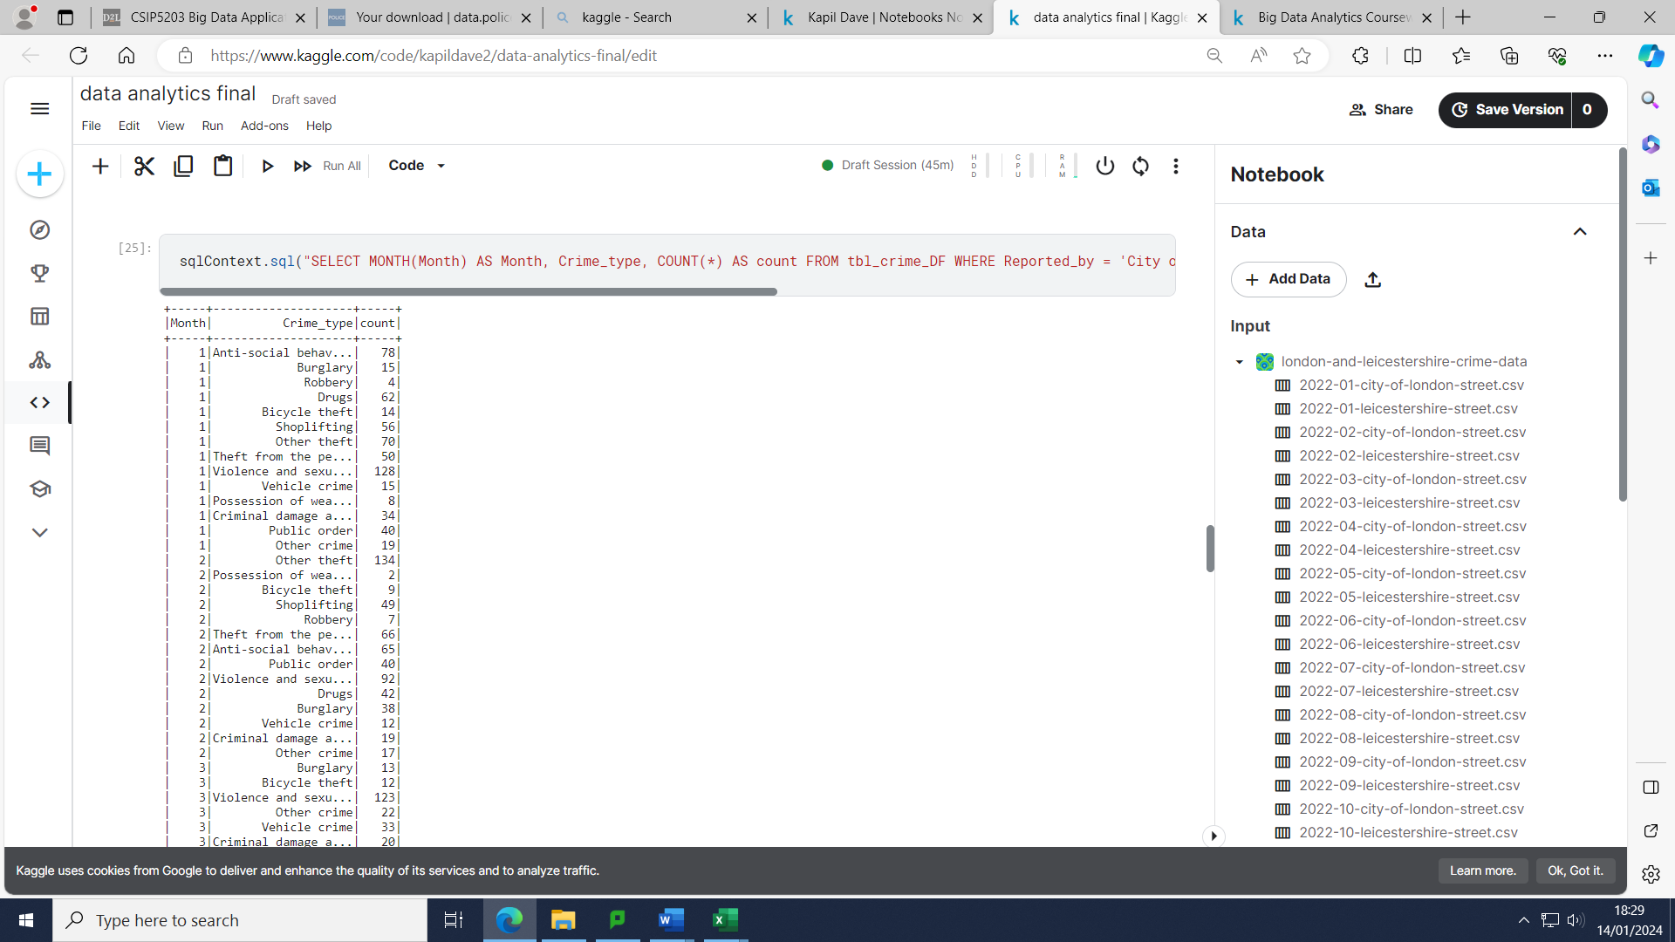

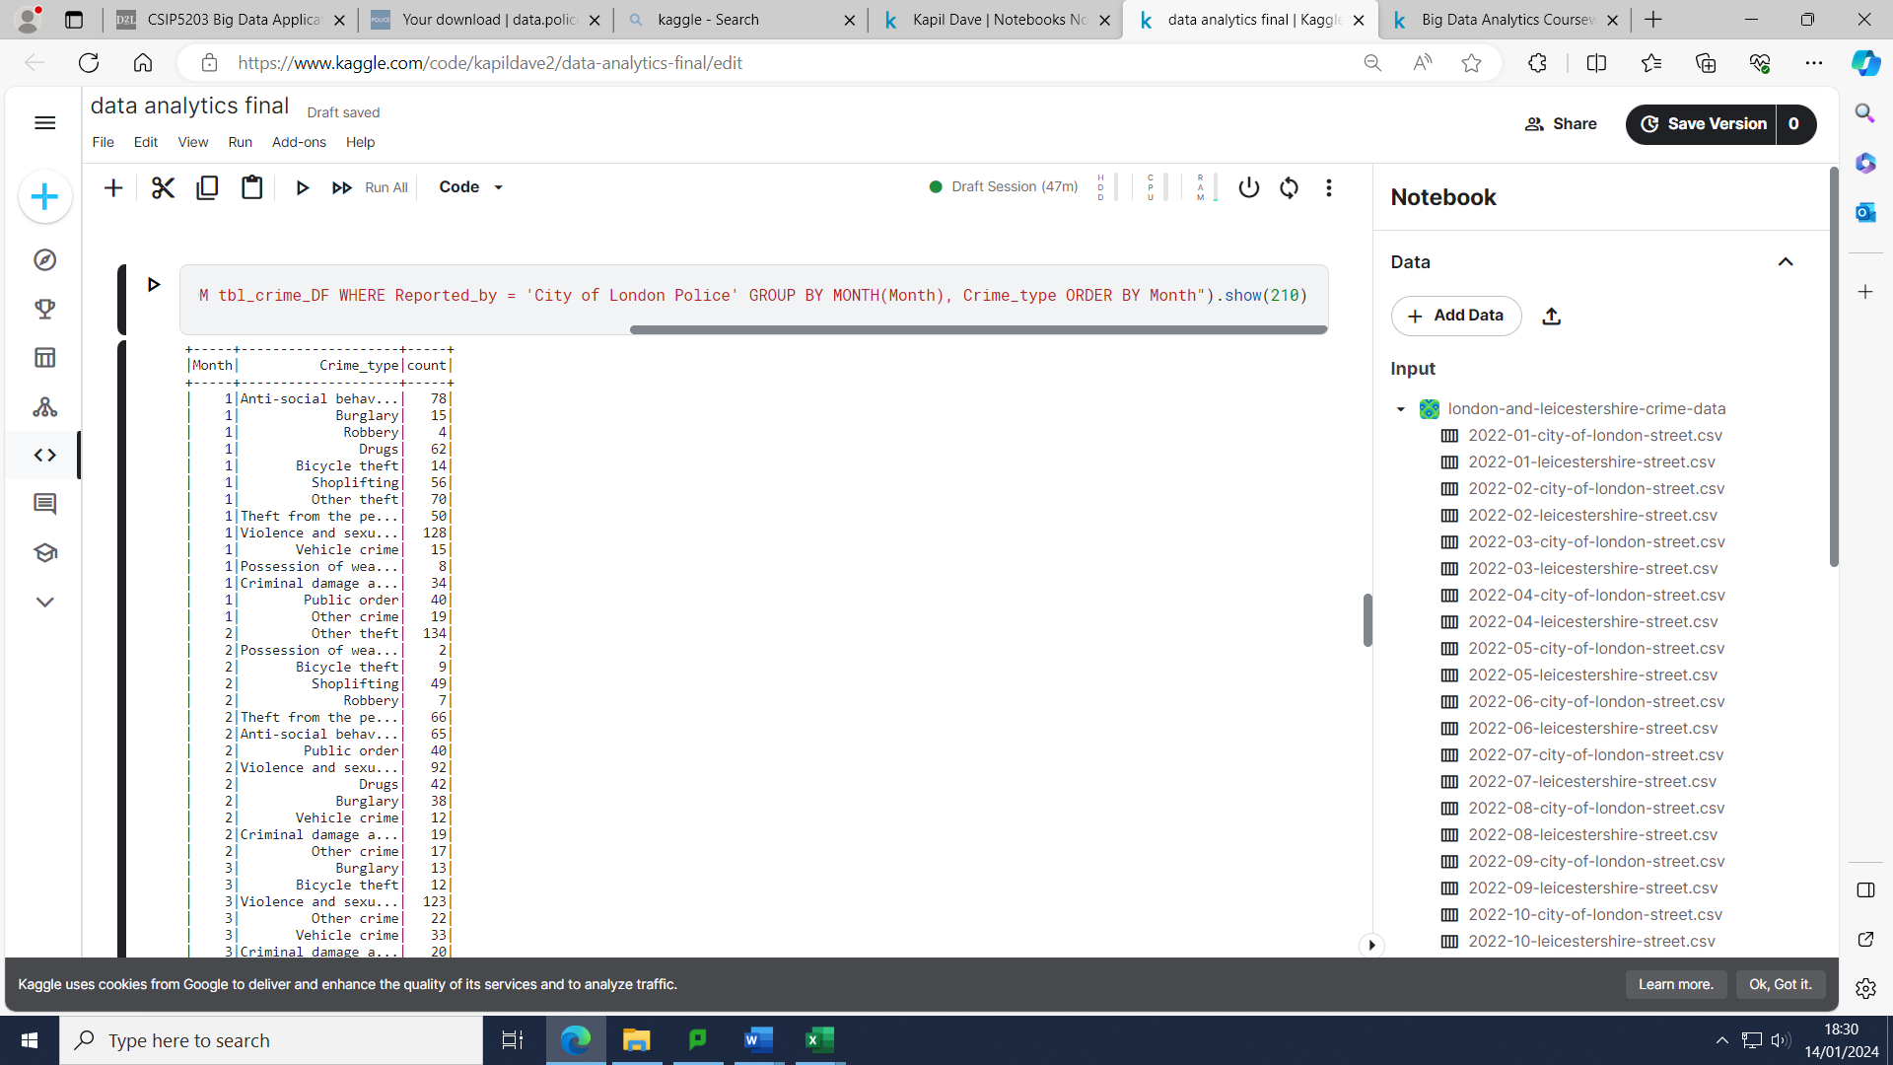

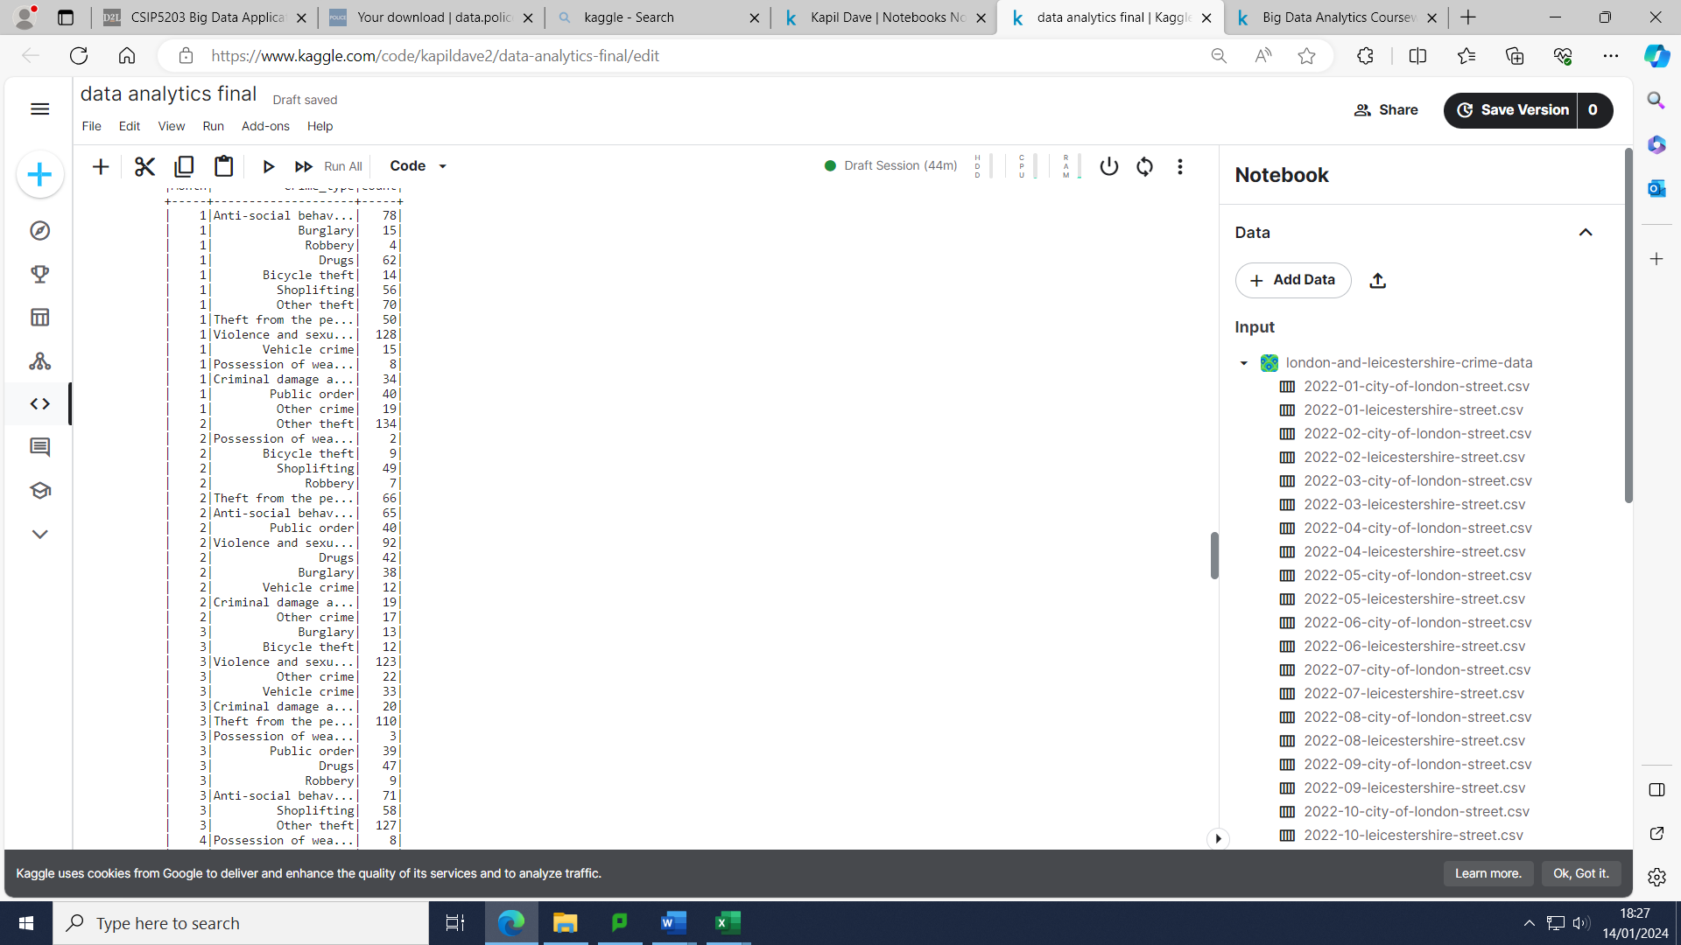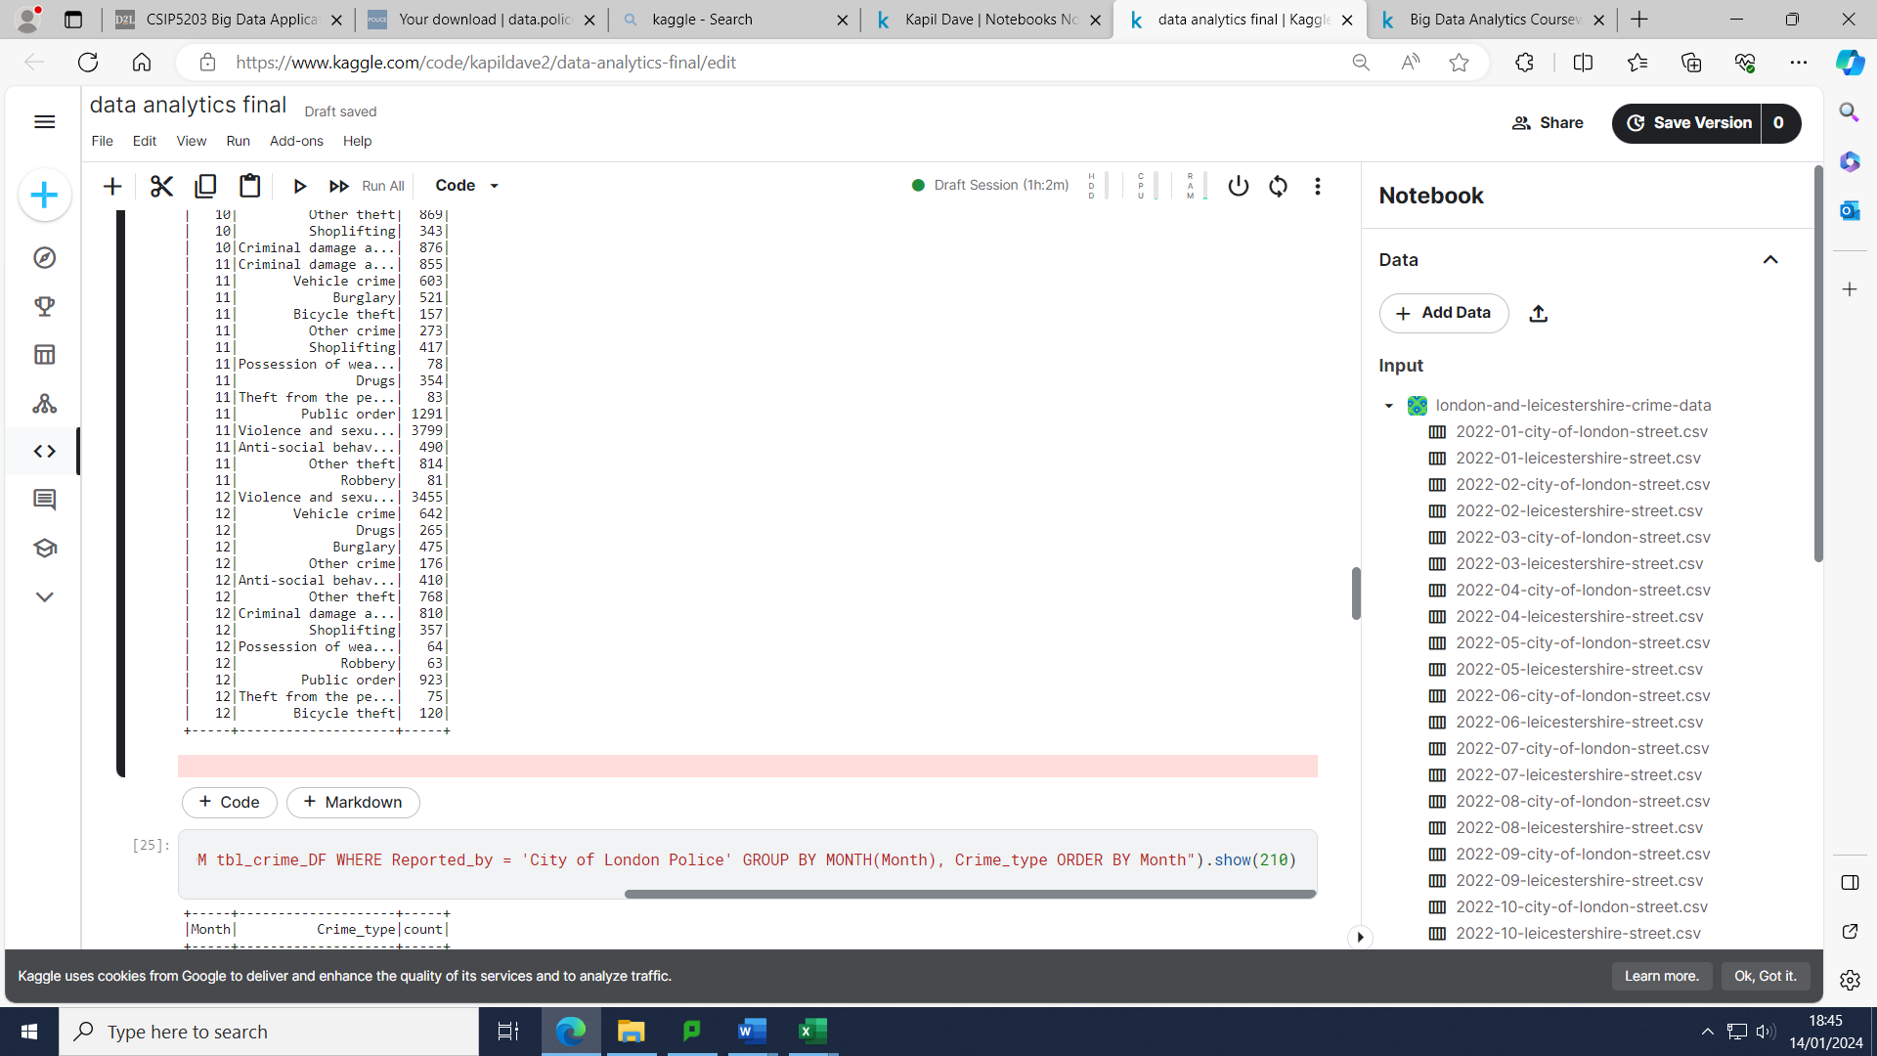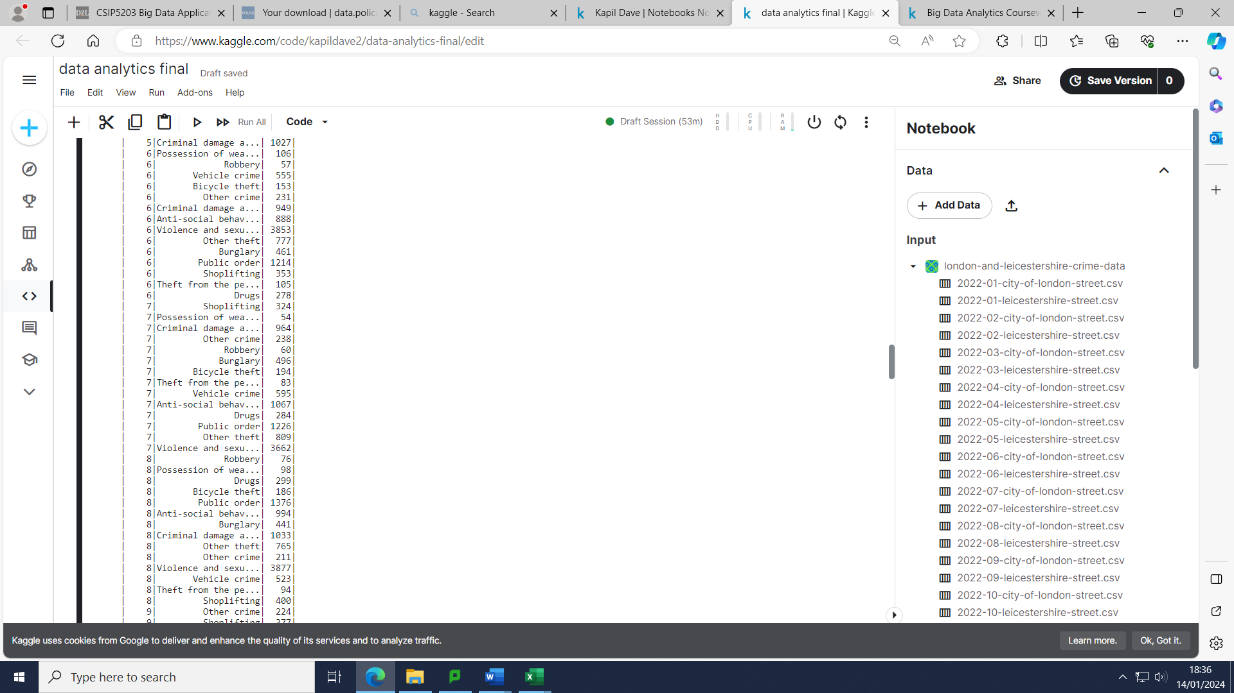

I have chosen the month above according to the seasons where there is the peak of the winter period and summer period respectively for both chosen cities. January, February, November and December for the winter period and June, July and August for the summer period to test the hypothesis above along with March being included to see the impact of the end of COVID-19 restrictions on crime types and count.

In Leicestershire Violence and Sexual offences on average were higher during the winter (3338 +3339+3799+3455/4=3482.75) compared to the summer (3853+3662+3877/3=3797.33). This was the same in the City of London with there being an average of 122.67 crimes related to violence and sexual offences in the summer compared to 112.5 during the winter months. The number of all types of thefts was a lot greater during the summer in the city of London compared to the winter with July alone having 321 thefts and January and February combined having 343 thefts which would be a major reason July had the month with the highest crime count.

On average there were more burglaries in the Winter period in the City of London with 29.5 per month and 24.67 during Summer. However, this was not the case in Leicestershire with 466 per month during the summer period relative to 451 per month during the Winter period. Overall, the average burglaries were 240.25 per month across both cities in Winter and 245.33 per month during the Summer.

In Leicestershire, there was a drastic increase in Violence and sexual offence-related crimes from February 2022 (3339) to March 2022 (3854) along with anti-social behaviour (an increase from 727 to 887). This would be further proof of how the easing of COVID-19 restrictions may have led to more crimes of this nature being reported with more interactions in outdoor spaces, especially nightclubs etc.

Conclusion

To conclude we have discovered that Leicestershire had a greater amount of crime compared to the City of London. Violence and sexual offence-related crime had the most reports in Leicestershire during 2022 and other thefts (mobile phone thefts) had the most reports in the city of London. Both cities had the most crimes reported overall during the summer period with Leicestershire having a significant difference. Temperature seems to have a great impact on the amount of crime related to Violence and Sexual offences whereas the cold weather did not seem to affect the number of burglaries overall across both cities. The easing of COVID-19 restrictions had an impact on crime rates with greater frequency of interactions in public spaces. For future work we need to learn to develop strategies to reduce crime related to Violence and sexual harassment especially during summer.

Task 2 – Big Data Analytics

Introduction

Titanic launched on the 31st May in 1911 and set sail on the 10th of April in 1912. Then disaster struck with the Titanic hitting an iceberg and breaking apart and sinking to the bottom of the ocean. Many lives got taken by this accident. We are trying to predict the survival rate using different classification methods with respect to certain categories. The dataset contains 891 rows of passengers who were inside the Titanic. The categories within the dataset includes the passenger class, Name, Sex, Age. Number of sibling and spouses, Parents/children on board, Ticket Number, fare, cabin, Passenger fare and lastly if they survived the sinking (www.noaa.gov, 2018).

I am pre-processing the data with the process of data cleaning, data transformation and data reduction using PySpark function. I will next ensure the data is ready for the Machine learning algorithms (Naïve Bayes and Logistic Regression) by using the Vector Assembler, String Indexer and Pipeline classes from PySpark. I will then split my data into training and testing before I will finally get to my final objective which is to compare the models in terms of accuracy, precision, recall and also with the use of a Confusion Matrix and then concluding which is best model to predict the survival rate on Titanic.

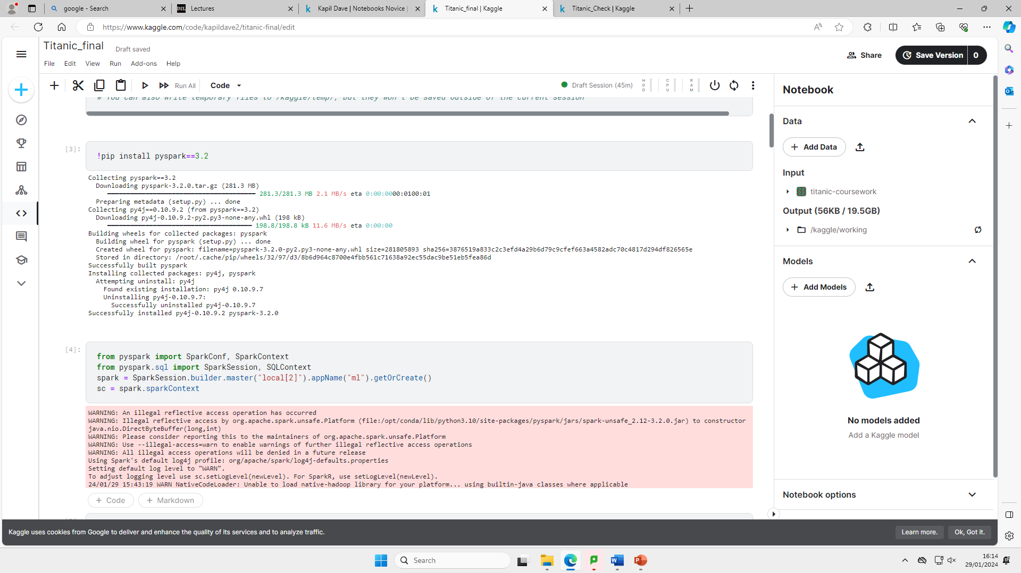Approaches

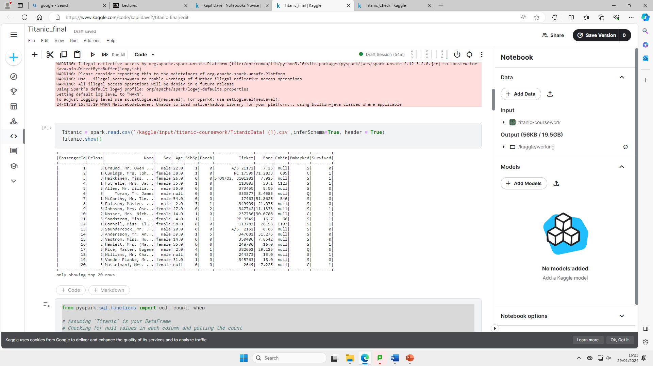I initially uploaded the Pyspark library for data pre-processing with the use of Kaggle to maintain consistency throughout the analysis.

I next uploaded my dataset (csv file) with the use of a Pyspark data frame which I named Titanic. This also included an inferred schema and header information.

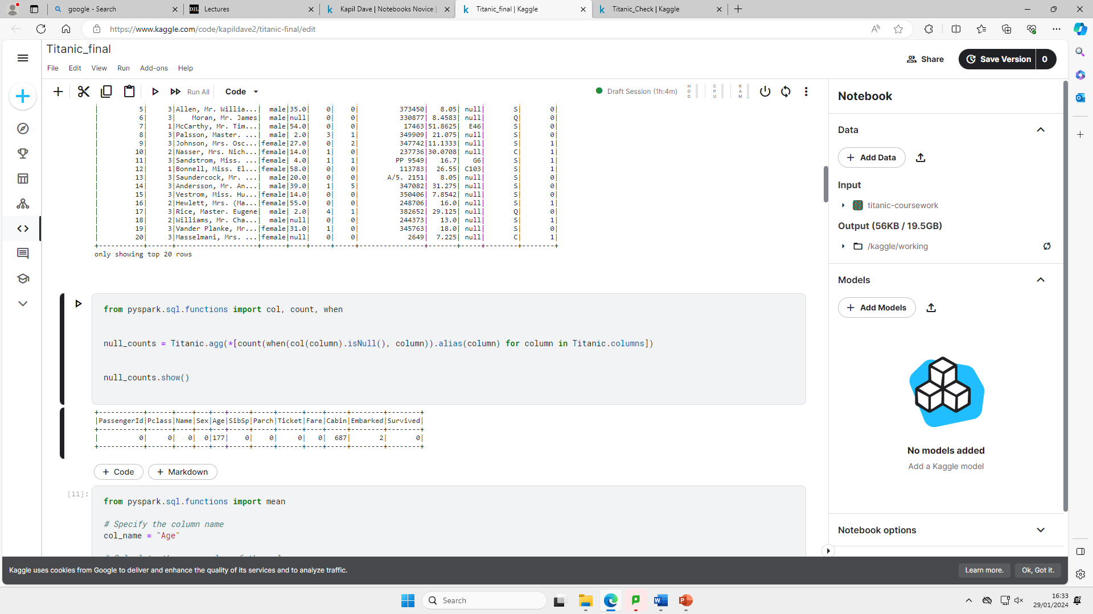

My first step of pre-processing the data is to check the count of null values within the dataset in each column. I have used (Spark by {Examples}, 2021) to help assist me with this step.

I have noticed here that there are 177 null values for the age column and 687 null values for the cabin column and 2 for the embarked column. I replaced the null values for the age column with the mean value of the ‘Age’ column and I dropped the ‘cabin’ and embarked column as the cabin column had far too many null values and the ‘embarked’ column was not required for predicting the survival rate. I also dropped the ‘Parch’, ‘passengerId’, ‘Name’, ‘SibSp’, ‘Fare’ and ‘Ticket’ column



Above are the codes which I used to replace the null values of age with the mean value and drop the columns mentioned above. I have used (Zach, 2023) to help assist me with replacing the null values of age with the mean. I have also used (Zaman, 2023) to help dropping the irrelevant columns which I do not require.

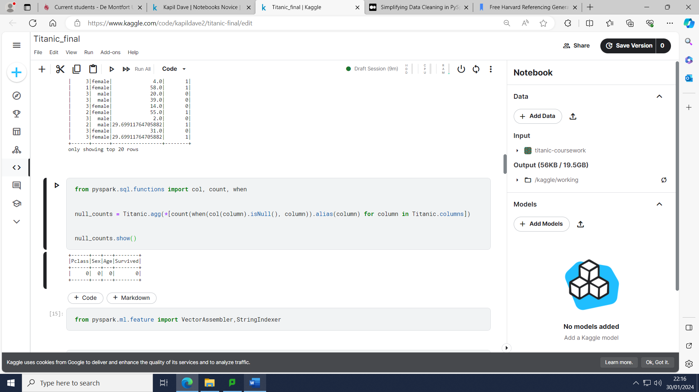

As you can see from the figure above, we only had 4 columns remaining and no null values within our updated dataset after the data pre-processing steps had been carried out.

To initiate the next step which is called Feature selection/ Extraction/transformation we started off by importing the relevant library as shown by the figure below.

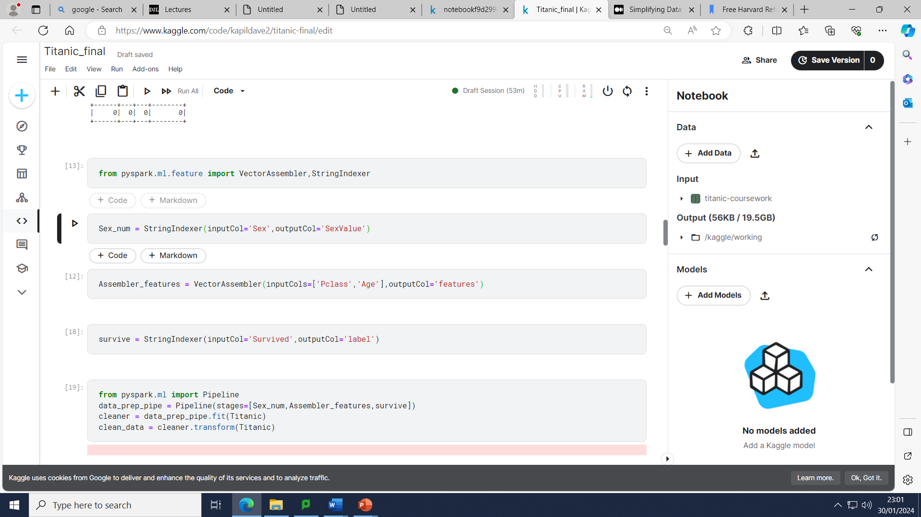

The next step we carried out was to convert the ‘sex’ column from categorical data to numerical data. For this transformation step we used String Indexer class where converted string variables (‘Male’ and ‘female’) to numerical values (0 and 1). This is as most machine learning algorithms do not take categorical data. This is shown on the figure below.

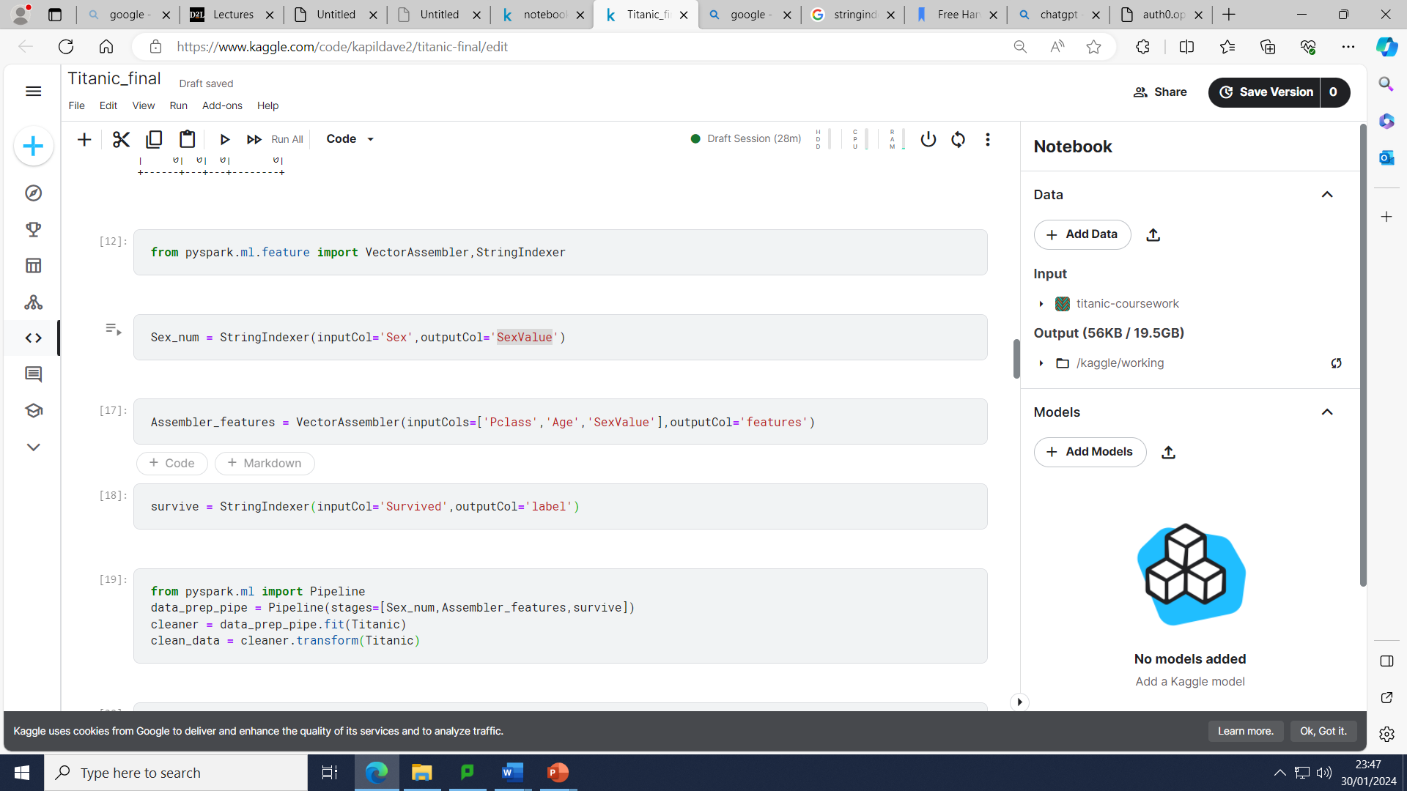

I next used a Vector Assembler library and named it “Assembler_features”. I used Pyspark library to run this step. This step is required to enable Machine Learning libraries and algorithms to run efficiently as they require each input row to be in a single vector column. This is shown by the figure below.



The next step was to enable the “survived” column to be in a numerical indices format for machine learning algorithms and can be used as a target variable for training a machine learning model. We have used the ‘String indexer’ class as shown below.

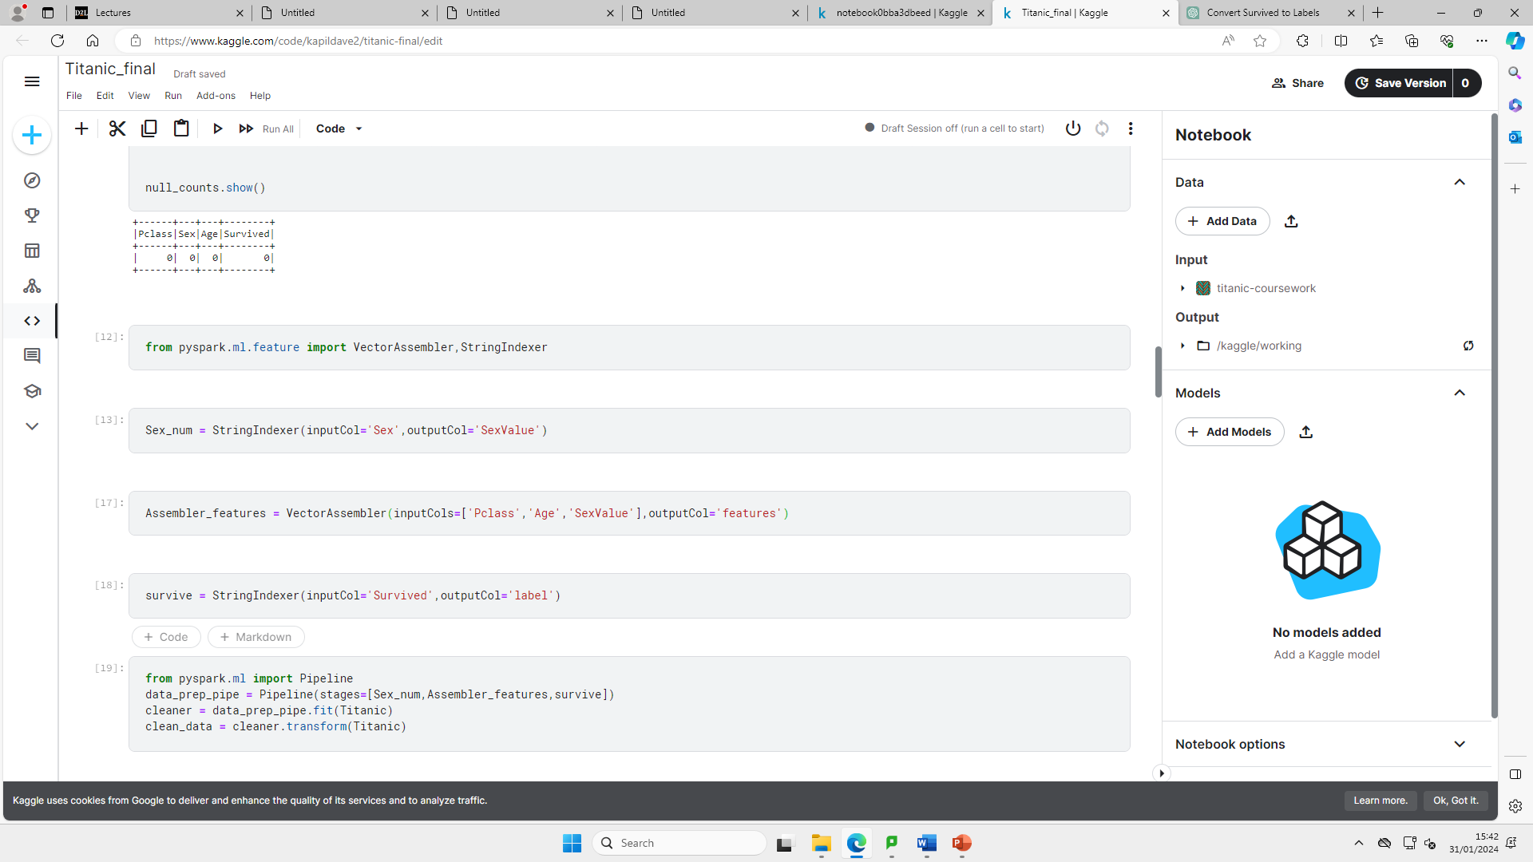

The next step involves me using the Pipeline class from Pyspark to help clean and transform the data to ensure, it is ready for machine learning algorithms. Pipeline is specified as a sequence of steps with each step being a transformer or estimator (spark.apache.org, n.d.). The figure below involves building up the pipeline by combining the data pre-processing methods.

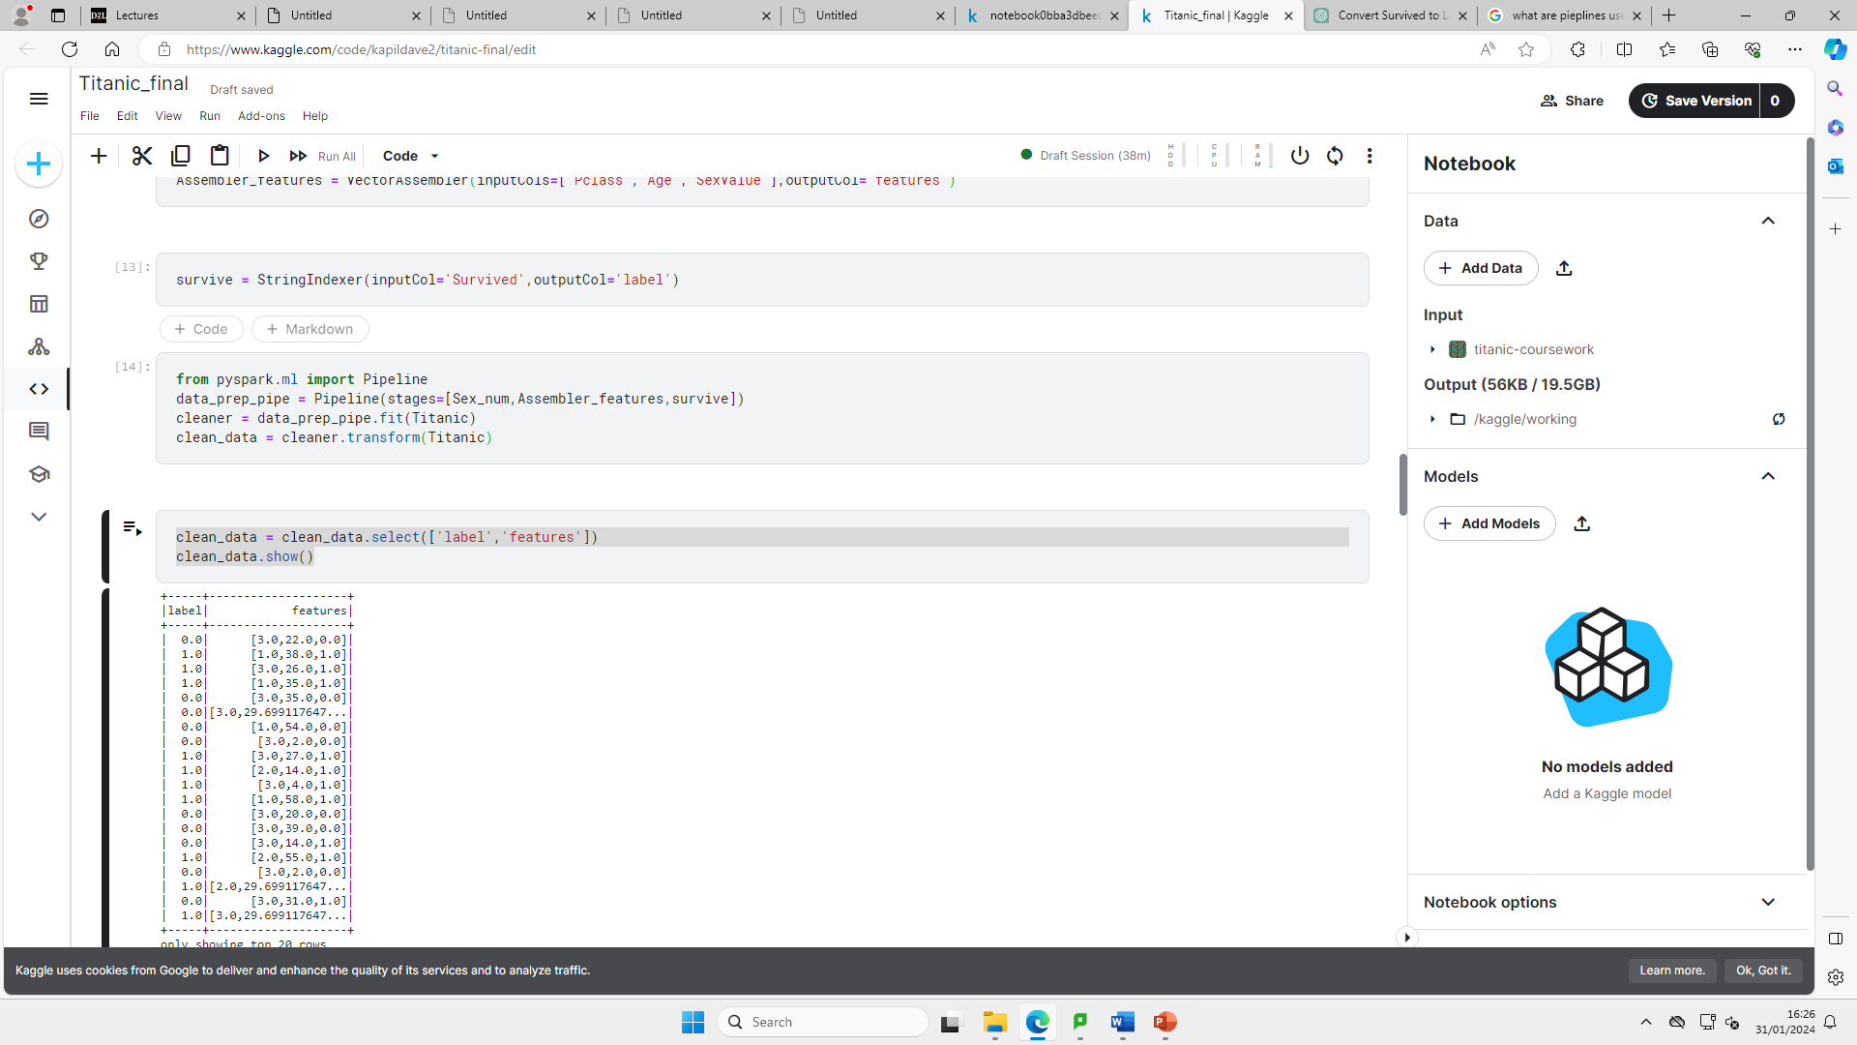

The last step before applying the machine learning algorithms involves us using the Titanic pipeline for fitting/transformation purposes and applying them to the relevant column’s mentioned below and showing the output.





We next split the data into training and testing with 70% training and 30% testing as shown above.

The two machine learning algorithms we choose were the Naïve Bayes method and Logistic regression method. The reason I choose both of these methods were as they are both very efficient to implement, interpret and train (Vadapalli, 2020) (Rout, 2020).

Naïve Bayes



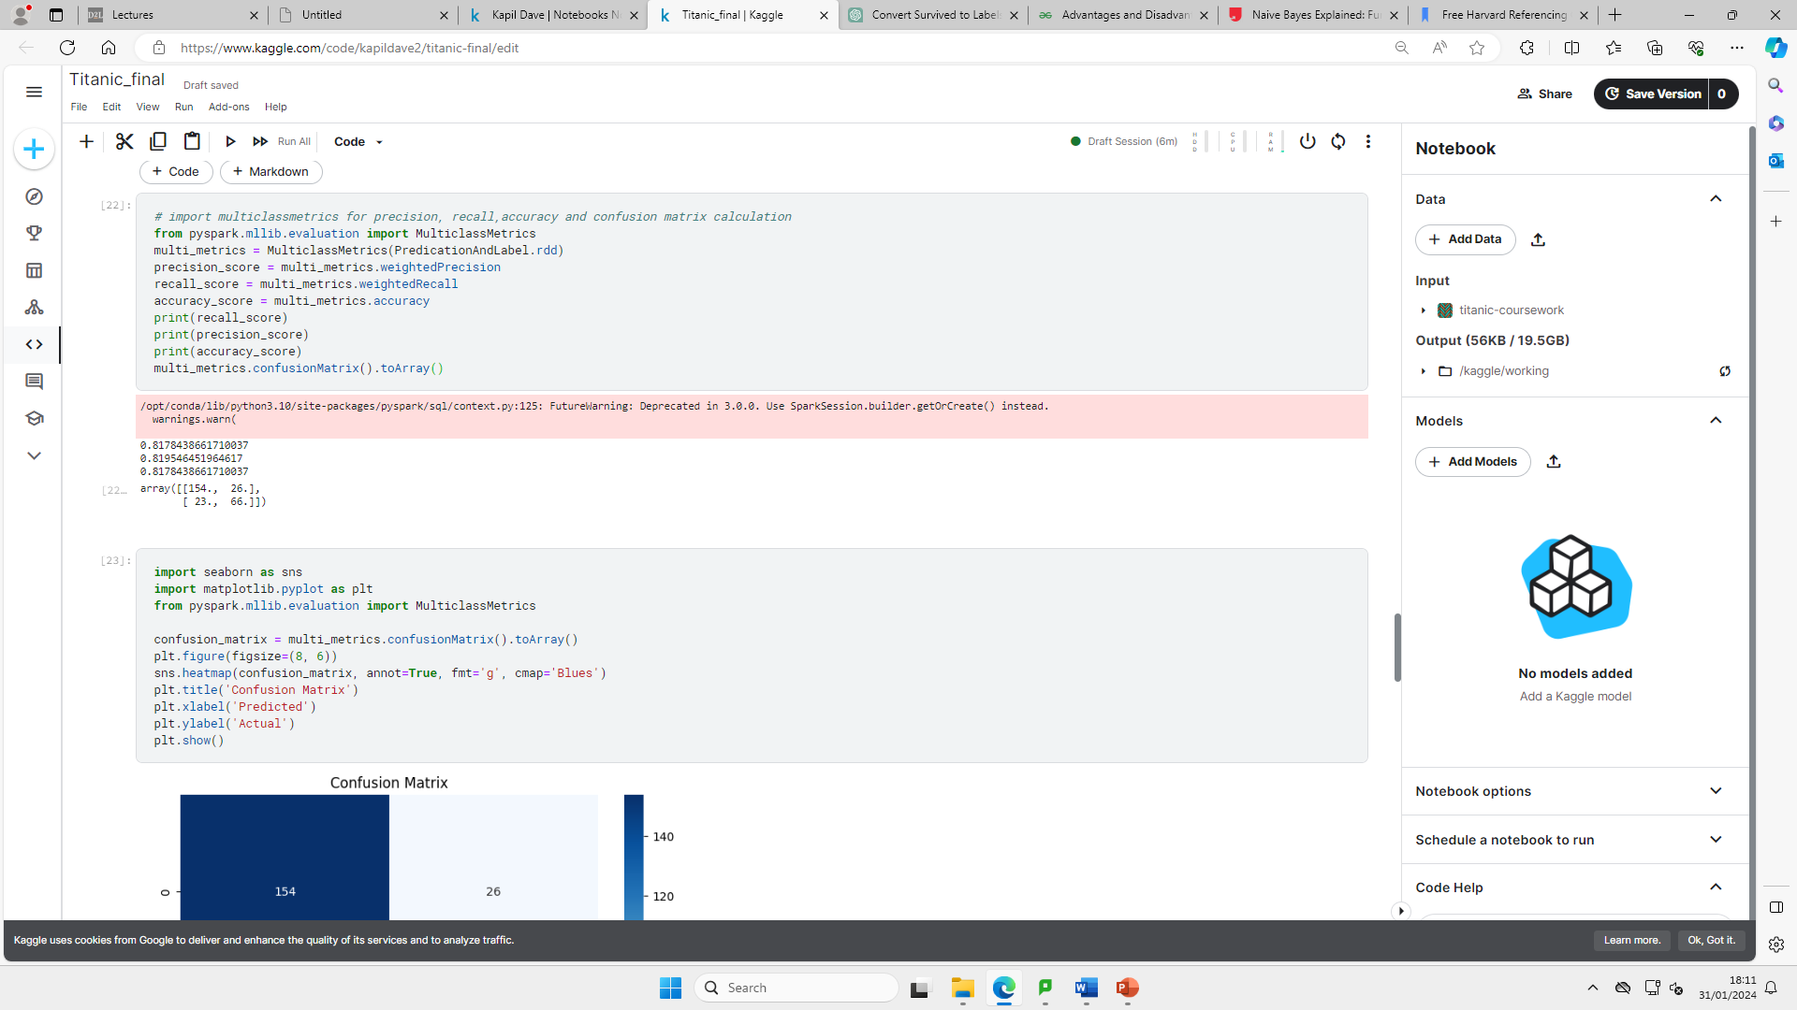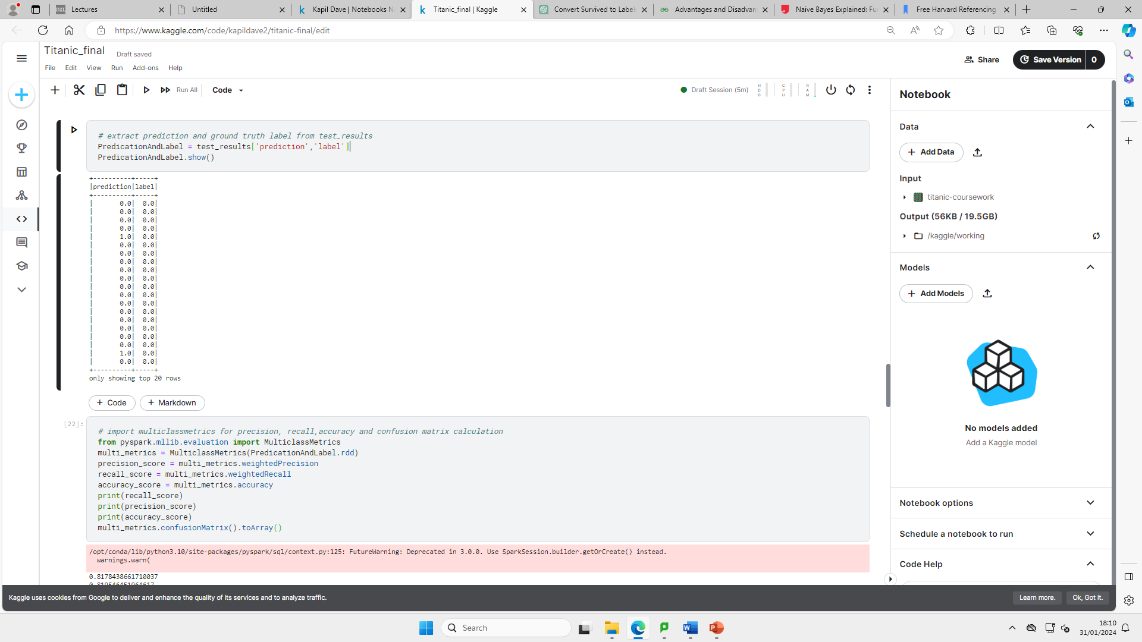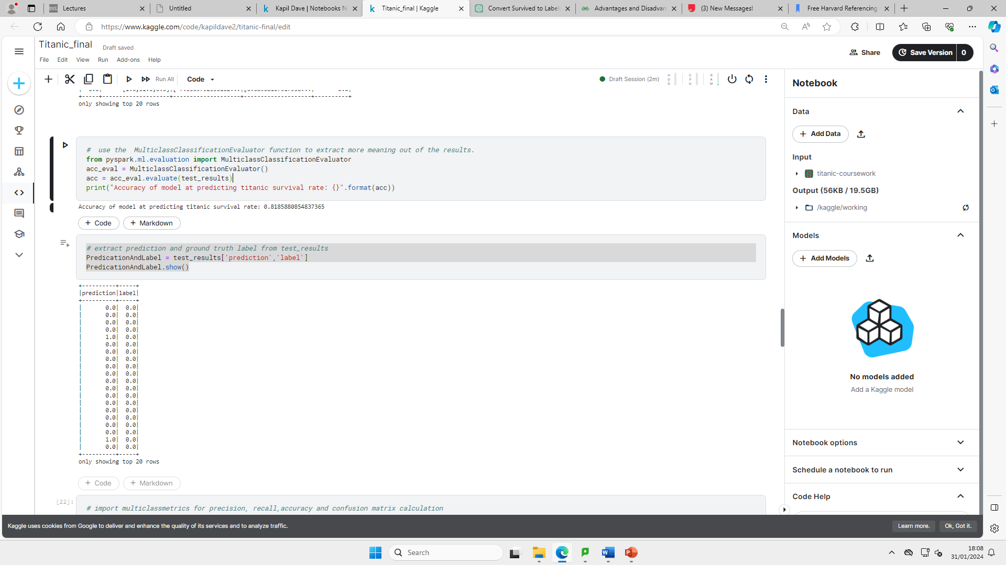

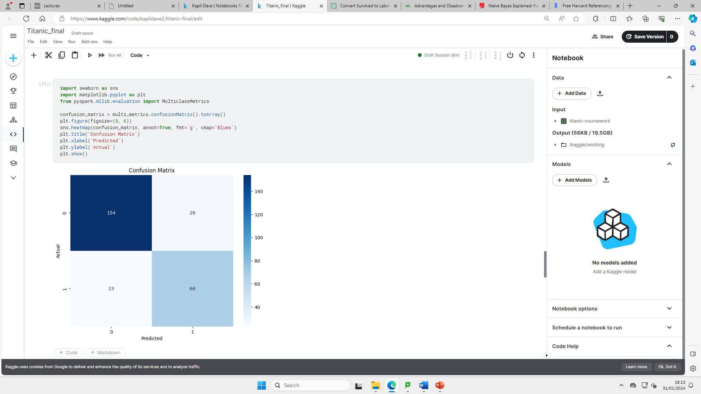

Above we have uploaded the Naïve Bayes classification method before training the model using training data and making predictions on the testing data. We next showed the test results. We then checked the performance of the naïve model with the use of ‘Muticlassclassificationevaluator’ class in terms of accuracy on the testing data. We next created the prediction column using the Naïve Bayes model and the label column contains the actual labels from the testing data. The next step involves us working out and print precision, recall and accuracy scores for the Naive Bayes model. We also printed the confusion matrix in 2D format. For visualisation purposes I then used a heatmap for the confusion matrix to interpret how the model is performing for each class.

We then carried out the same steps for the Logistic Regression model, before comparing each model as shown by the codes below.

Logistic regression

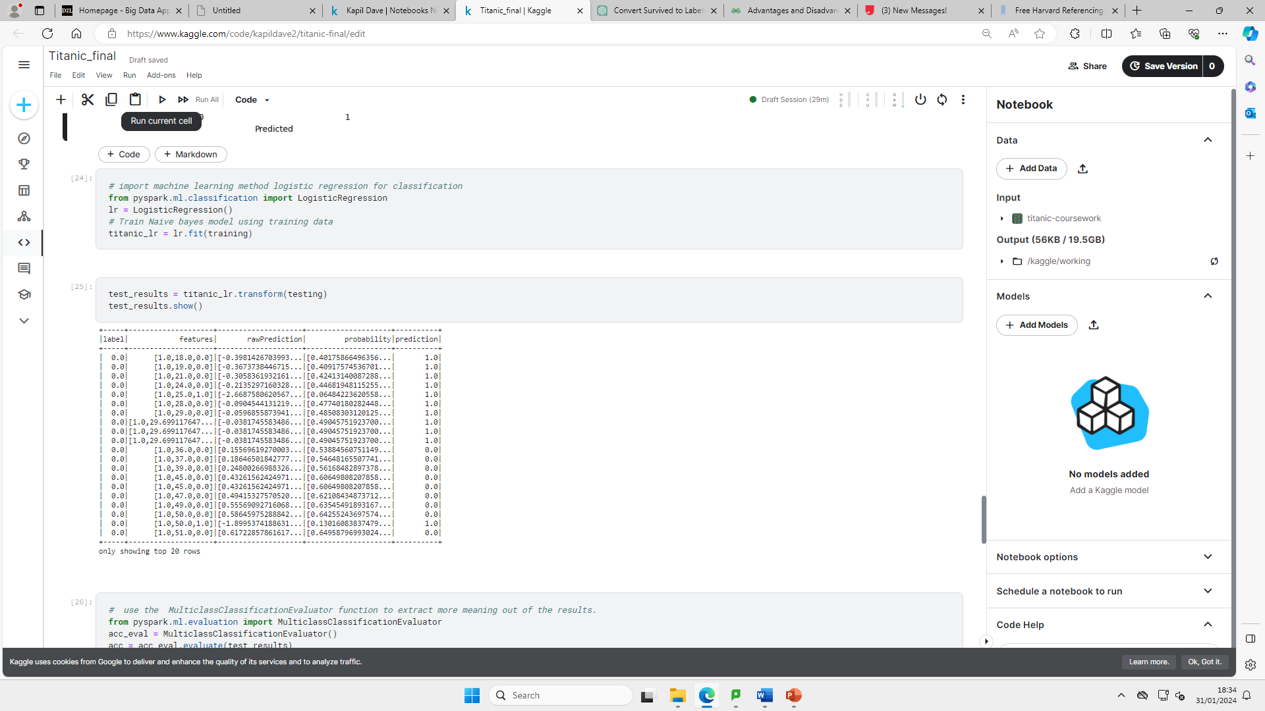

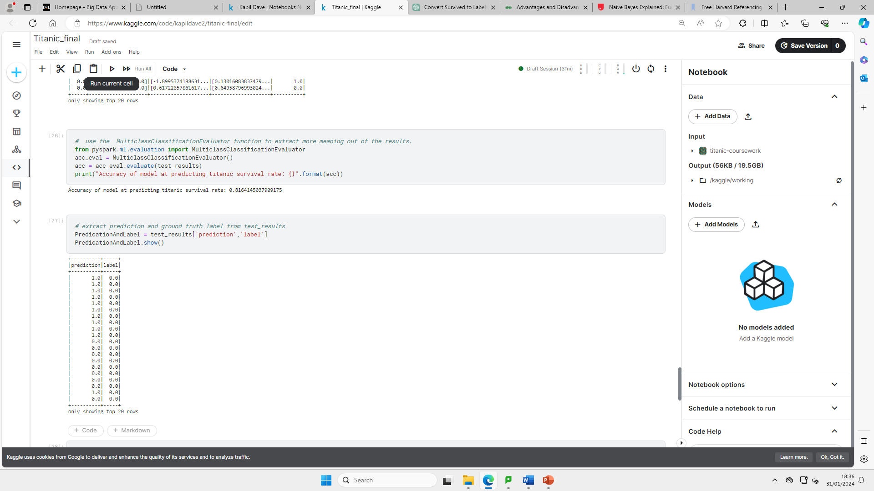

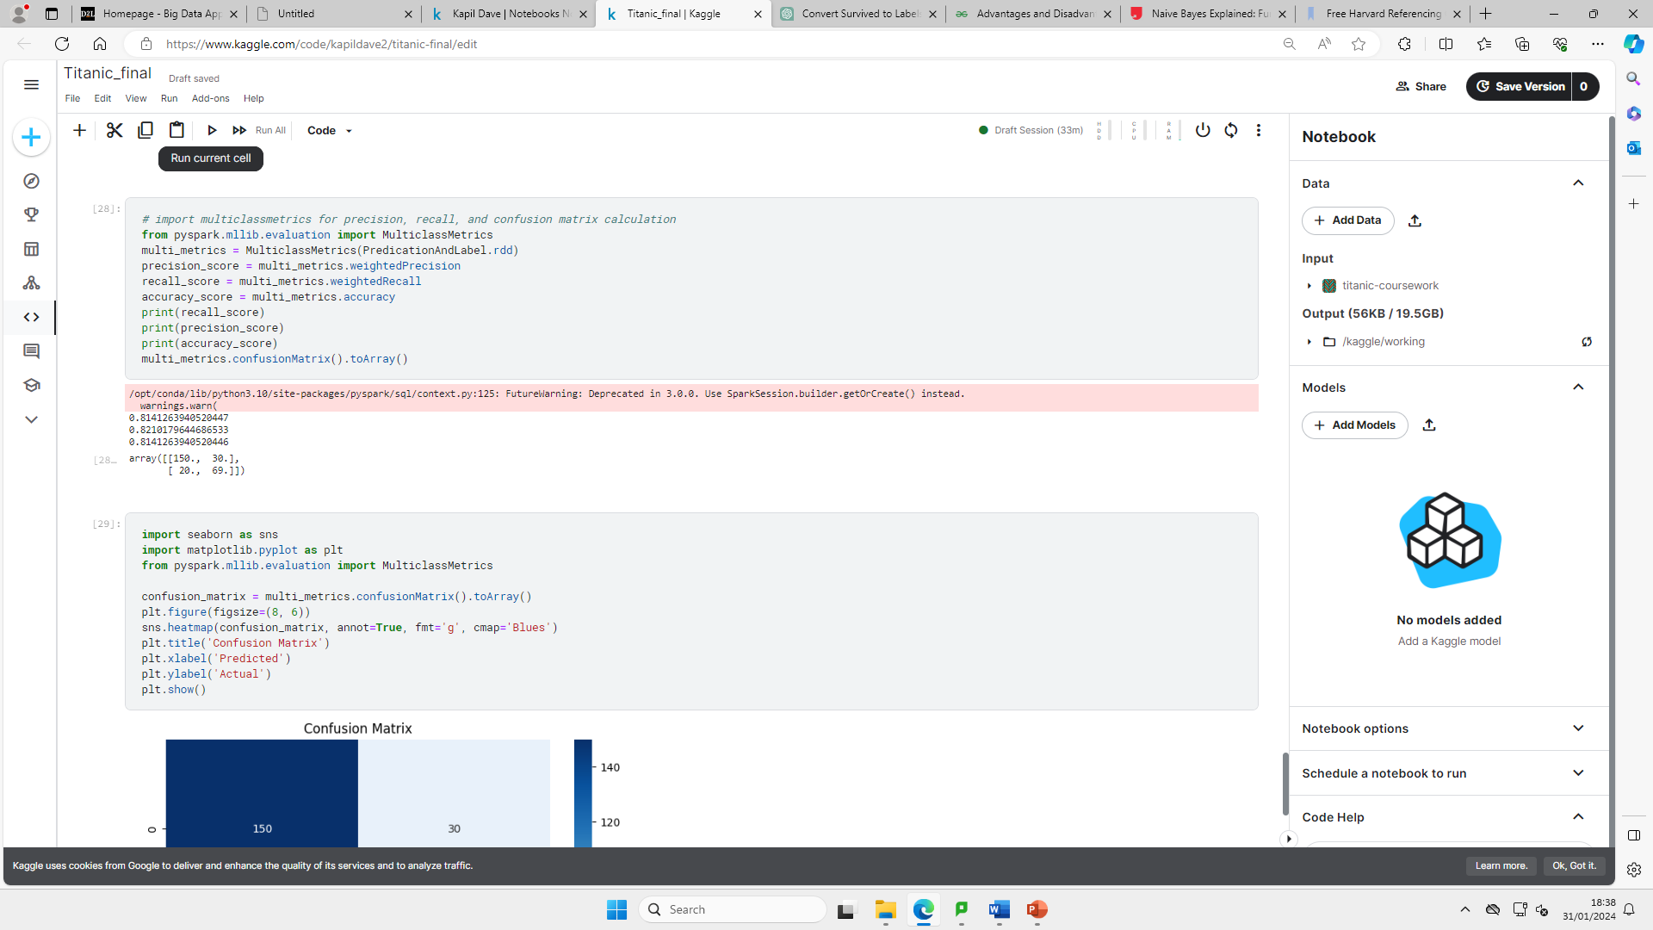



Results Analysis

To compare both models in terms of the Accuracy, precision and recall metric it is important to understand what each of them are a measure off.

(www.evidentlyai.com, n.d.)

|  |  |
| --- | --- |
| Metric | Comments |
| Accuracy | Shows how often a classification ML model is correct overall. It is measured by correct measurements/all predictions. Higher percentage=more accurate |
| Precision | This metric would show how often a machine learning model correctly predicts the positive class. It is calculated by true positives/true positives + false positives. Higher percentage=better precision |
| Recall | Recall is a metric which measures how often a machine learning algorithm identifies positive instances from all the actual positive samples in the dataset. Calculated by true positives/true positives/+False negatives. Higher percentage= better Recall |



Naïve Bayes metrics visualisations



Logistic Regressions metrics visualisations

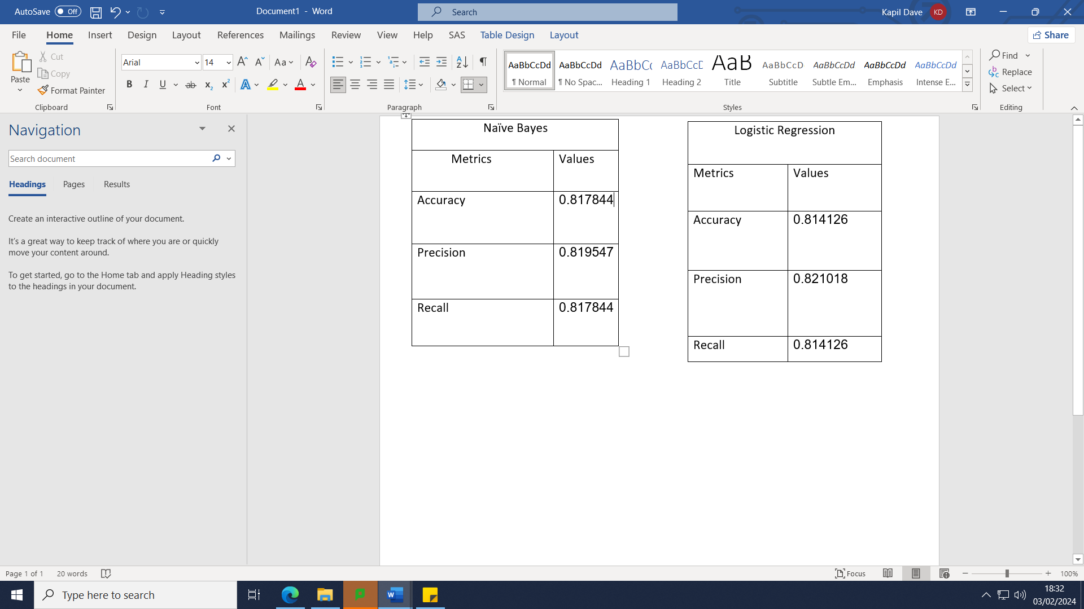



Percentage change formula (LLC, 2006)

From the table above we can that the Naïve Bayes model is 0.56% more correct at predicting the survival rate overall (accuracy), the logistic regression model identifies the positive class (survived) amongst all predicted positives 0.18% more often (Precision) and the Naïve Bayes identifies positive instances from all actual positive samples in the dataset 0.45% more (Recall).

Confusion Matrix

A confusion matrix is a table which compares and contrasts the performance of a classification model by comparing it’s predicted labels to the true labels. It will show the number of true positives (TP), True negatives (TN), False positives (FP) and False negatives (FN) of the model predictions.

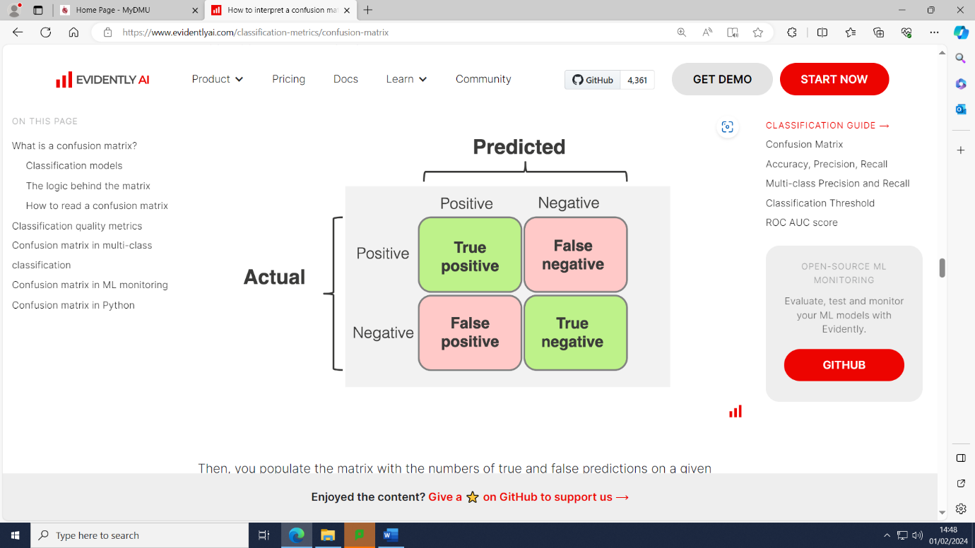

(www.evidentlyai.com, n.d.)



Naïve Bayes Confusion matrix



Logistic Regression Confusion Matrix

In our case the Naïve Bayes model predicts those who survived correctly on 154 instances whereas the Logistic Regression model on 150 instances (TP). The Naïve Bayes model predicts those who died correctly 66 times whereas the logistic regression model 69 times (TN). The Naïve Bayes model predicts those who survived incorrectly 23 times and the Logistic regression model on 20 instances (FP). The Naïve model predicts those who died incorrectly on 26 instances whereas the logistic regression on 30 instances (FN).

Conclusion

In our case both machine learning models have very good accuracy, precision and recall value with each of them being slightly above 80% with minimal difference between them. The Naïve Bayes model has a slight advantage over the Logistic Regression model with slightly higher accuracy and recall values and also by the fact that the Logistic Regression model shows slightly more false predictions according to the confusion matrix. Pre-processing is one of the reasons we got excellent accuracy metrics for both models.

Word count (2703) - not including references

References

www.leics.police.uk. (n.d.). *Information on Leicestershire Police*. [online] Available at: <https://www.leics.police.uk/police-forces/leicestershire-police/areas/leicestershire-force-content/about-us/about-us/>

[Accessed 15 Jan. 2024].

‌Greater London | county, England, United Kingdom | Britannica. (2019). In: *Encyclopædia Britannica*. [online] Available at: <https://www.britannica.com/place/Greater-London>. [Accessed 15 Jan. 2024].

Office for National Statistics (2022). *How the population changed in City of London, Census 2021 - ONS*. [online] www.ons.gov.uk. Available at: <https://www.ons.gov.uk/visualisations/censuspopulationchange/E09000001/>

[Accessed 15 Jan. 2024].

www.leicestershire.gov.uk. (n.d.). *Census reveals growing county | Leicestershire County Council*. [online] Available at: <https://www.leicestershire.gov.uk/news/census-reveals-growing-county>. [Accessed 15 Jan. 2024].

Mobile phone stolen every six minutes in London, says Met Police. (2023). *BBC News*. [online] 9 Aug. Available at: https://www.bbc.co.uk/news/uk-england-london-66442069[Accessed 15 Jan. 2024].

‌

Police, city of L. (2023). *Phone snatching halved in the City of London*. [online] Available at: https://www.cityoflondon.police.uk/news/city-of-london/news/2023/november/phone-snatching-halved-in-the-city-of-london/ [Accessed 15 Jan. 2024].

‌

Anon, (2023). *What are crime rates like in 2022 - EM Security*. [online] Available at: https://emsecurityandfire.co.uk/resources/crime-rates/what-are-crime-rates-like-in-2022/#:~:text=Looking%20at%20the%20broader%20picture

[Accessed 15 Jan. 2024].

‌

Moorhouse, S. (2023). *Sex crimes committed in Leicester triple in space of a decade*. [online] Leicestershire Live. Available at: https://www.leicestermercury.co.uk/news/local-news/sex-crimes-carried-out-leicester-8527820 [Accessed 15 Jan. 2024].

‌

Aid, C. (2022). *What are the Current Covid Rules in England?* [online] covid:aid. Available at: https://covidaidcharity.org/advice-and-information/current-covid-rules-england [Accessed 15 Jan. 2024].

team, R.C. (2018). Reality Check: Why there’s more crime in a heatwave. *BBC News*. [online] 19 Jul. Available at: <https://www.bbc.co.uk/news/uk-44821796> [Accessed 15 Jan. 2024].

Spark by {Examples}. (2021). *PySpark – Find Count of null, None, NaN Values*. [online] Available at: <https://sparkbyexamples>.com/pyspark/pyspark-find-count-of-null-none-nan-values/.

‌Zach (2023). *PySpark: How to Fill Null Values with Mean*. [online] Statology. Available at: <https://www>.statology.org/pyspark-fillna-with-mean/ [Accessed 29 Jan. 2024].

‌

Zaman, A.U. (2023). *Simplifying Data Cleaning in PySpark: Using the drop() Function to Remove Columns*. [online] Medium. Available at: <https://medium>.com/@uzzaman.ahmed/simplifying-data-cleaning-in-pyspark-using-the-drop-function-to-remove-columns-f96239d2e553#:~:text=drop()%20is%20a%20function [Accessed 30 Jan. 2024].

‌

Vadapalli, P. (2020). *Naïve Bayes Explained: Function, Advantages & Disadvantages, Applications in 2020*. [online] upGrad blog. Available at: <https://www>.upgrad.com/blog/naïve-bayes-explained/.

‌

Rout, A.R. (2020). *Advantages and Disadvantages of Logistic Regression*. [online] GeeksforGeeks. Available at: <https://www>.geeksforgeeks.org/advantages-and-disadvantages-of-logistic-regression/.

‌

Spark.apache.org. (n.d.). *Overview: estimators, transformers and pipelines – spark.ml – Spark 1.6.1 Documentation*. [online] Available at: <https://spark>.apache.org/docs/1.6.1/ml-guide.html#:~:text=A%20Pipeline%20is%20specified%20as [Accessed 31 Jan. 2024].

‌

[www.noaa](http://www.noaa).gov. (2018). *R.M.S Titanic – History and Significance*. [online] Available at: <https://www>.noaa.gov/gc-international-section/rms-titanic-history-and-significance.

‌

[www.evidentlyai](http://www.evidentlyai).com. (n.d.). *Accuracy vs. precision vs. recall in machine learning: what’s the difference?* [online] Available at: <https://www>.evidentlyai.com/classification-metrics/accuracy-precision-recall#what-is-recall.

‌

LLC, C. (2006). *Percentage Change Calculator*. [online] CalculatorSoup. Available at: <https://www>.calculatorsoup.com/calculators/algebra/percent-change-calculator.php.

‌[www.evidentlyai](http://www.evidentlyai).com. (n.d.). *How to interpret a confusion matrix for a machine learning model*. [online] Available at: <https://www>.evidentlyai.com/classification-metrics/confusion-matrix.

‌

‌